Aim: How did the Spanish use race to control their colonies?
Topic: Dehumanization of races under Spanish Colonialism

Document #1: The New Social Class System
To control the colonies and the different races that lived there, the Spanish created a new Social Class System.
The Peninsulares were the European Spanish. They were the fewest in number, but had the most land, legal rights and political power. As you go down the pyramid, then number of people increase, but their rights and power decrease.
Creoles: Spanish parents but born in the new world.
Mestizos: Mix of Indian and Spanish
Mulattoes: Mix of African and Spanish
Native Americans
Africans: enslaved Africans (and free) Africans brought from Africa.

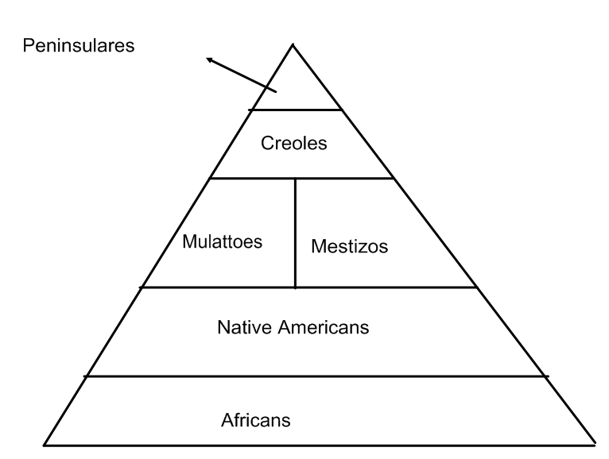
1) Who has the most power in this system? Why do you think they have the most power?

2) Do you think this is a fair system? Explain.

Document #2: Spanish Racism Institutions
One of the first acts the Spanish did was to force the Indians to convert to Catholicism. This was done to help control the population and to get rid of their old religions. In addition to controlling the population with religion, the Spanish created racial laws. Laws were written that defined a wide range of racial categories, including black, mestizo, quadroon and octotroon. Each category had its own set of legal restrictions and rights based on the person’s racial mix. The “lighter” a non-European was, the higher they were permitted to climb the social pyramid.
1) How did the Spanish control the different races?

Document #3: Slavery in the West Indies
In the West Indies, African slaves made up 80 to 90 percent of the population. Cruel punishments were used, such as tying slaves down and flogging (beating) them for nine to thirteen consecutive days. Slave-owners frequently sold slaves apart. Death rates among slaves in the Caribbean were high and suicide appears to have been common. The slave death rate was so high and the birth rate so low that slaves could not sustain their population without new imports of slaves from Africa. Profits were made from the production of cash-crops were so great that the frequent purchase of new slaves was worth the cost to the plantation owners. Planters relied heavily on Black managers who formed a distinct class of free blacks and mulattoes to serve as middle-men to control the slave population.
1) Why did plantation owners keep importing new slaves from Africa?

2) How were the slaves treated? Why do you think they were treated that way?

Document #4: Joachin Antonio de Bafaras, a Spanish expert in the science of racial categories (1763)
“It is known that neither the Indian nor Negro has the same dignity and worth with the Spaniard; especially the Negro, who is the “most dispirited and despised person.” It is agreed that from a Spaniard and a Negro and mulatto is born; from a mulatto and a Spaniard, a morisco; from a morisco and a Spaniard, a torna atras [retrun-backwards]; and from a torna atras and a Spaniard, a tente en el aire [hold-yourself in mid-air], which is the same as mulatto, so it is said, that the Spanish element that is lost and the off-spring will fall to the lowly condition of the Negro.
1) According to the writer, how does race affect a persons’ worth?

2) How does the “science” of racism support the institutions of racism?

