Aim: How does our macroeconomy operate and can we control it?
Topic: Aggregate Demand

Document #1: Introduction to Aggregate Demand
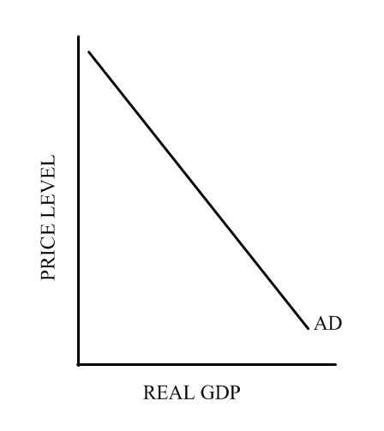
Aggregated Demand = total spending/total demand in the economy: Consumer Spending + Investment Spending + Government Spending + Net Exports C+I+G+X

Aggregate Demand function is an inverse function between the price level and output: as the price level rises, the level of output demanded decreases.

Factors that show why the demand curve is an inverse curve and that make movements along the demand curve:
1) Interest Rate Effect: When the price level increases, the real quantity of money (its purchasing power) decreases. People need more money even to continue their current consumption levels. This increases the demand for money in the form of loans, and decreases the supply of loanable funds (funds from a bank). To reach equilibrium in the money market, the interest rate (which is effectively the price of money as we saw with Fisher's hypothesis) must increase. The higher interest rates leads to a decrease in real GDP as households and firms put off major purchases and investment until future periods when the interest rate might be lower. Likewise, a decrease in the price level decreases interest rates and increases real GDP.

2) Wealth effect: When the price level increases, the value of assets such as cash and checking-account balances falls. These assets will purchase fewer goods when prices are higher. The real value (or purchasing power) of the assets thus declines and people buy less. Likewise when the price level falls, the purchasing power of people's assets increase, and they buy more.

3) Net export/foreign trade effect: when the price level in one country increases, the prices of imports from other countries become relatively less expensive. At the same time, exports from the country whose price level rose become relatively more expensive. Thus, more imported goods and services are purchased and fewer exports are sold. Domestic firms will also find it relatively more profitable to invest abroad. The decrease in exports and the increase in imports resulting from a higher price level lead to a decrease in real GDP (and vice versa).
When the price level of one country increases, there is a decrease in exports as well as a demand for imports which decreases GDP. However, when our price level is low and another country's is high, we export more and import less -- increasing our GDP
1) Why must aggregate demand be the formula for GDP?

2) According to the Aggregate Demand curve, what is the relationship between the price level and real GDP?

3) For each factor of aggregate demand: explain why each factor makes the Aggregate Demand curve an inverse curve of Price Level to Real GDP?
a) Interest Rate Effect
b) Wealth effect or real-balance effect
c) Net export effect

Document #2: Shifting the Aggregate Demand Curve

Below are a list of factors that Shift the aggregate Demand curve right (aggregate demand increases) or left (aggregate demand decreases), and what effects each of the four factors of Aggregate Demand. When one of these occur; then at the same price level, production and spending will be different.

Decrease (Shift to the left) | Increase (Shift to the right)
Consumption decreases when:  - expectations of decrease in inflation  - decreased incomes or wealth  - fear of jobs and income  - lack of consumer confidence  Investment decreases when:  - investors lose optimism  - Businesses expect less future sales  Government spending decreases when:  - Government carries out contractionary policies (policies that shrink the economy) such as:  - decrease in government spending  - decrease in the money supply (printing less money/having banks hold onto more money/raising the interest rates)  - increase in taxes  Net exports decrease when:  - foreigners lose preference for our products  - increase in exchange rate | Consumption increases would result from:  - Expectations of inflation or shortages in the future  - Increased incomes or wealth  - Optimism about jobs and income  - Consumer confidence  Investment increases when:  - Investors gain optimism  - Businesses expect higher future sales  Government spending increases when:  - Government carries out expansionary policies (policies that grow the economy) such as:  - increase in spending  - increase in the money supply (printing more money/having the banks release more money in economy/decrease in interest rates)  - decrease in taxes  Net exports increase when:  - foreigners develop preferences for our products  - decrease in exchange rate

1) How can government policy impact aggregate demand?

2) What is the difference between expansionary and contractionary policies?

3) What non-government factors can influence the economy?

4) Why is it important to have a positive balance in Net Exports?

5) Why is Consumer spending important to the economy?

6) Why is business spending important to the economy? Even though stocks are not counted in GDP, why is it important to watch the stock market?

7) Why might economists agree that businesses generate the most spending?

