Elasticity Review
Elasticity: The responsiveness of a product to change in price relative to the quantity demanded.
Elastic products will have a response where the quantity demanded (and thus the total revenue) is affected.
Inelastic products will not have a response where quantity demanded is affected (or drastically affected)
Price X Quantity = Total Revenue
If total revenue decreases due to a change in quantity, then the product is inelastic.
Elasticity rules:
*Elastic = Percentage change in quantity demanded greater than percentage change in price - answer is greater than or equal to 1
*Inelastic = Percentage change in quantity demanded is less than percentage change in price

To calculate elasticity you have to look at the percentage change in quantity demanded vs. the percentage change in price.
To calculate percentage of ARC (average/relative) elasticity:
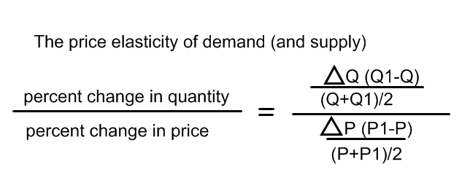
**Quantity is always on top**
**Price of other variable is always on the bottom**
**elasticity may vary along curve – this is known as relative elasticity, while if the entire unit is elastic it is known as unit elasticity**

Other forms of elasticity:
Price x Quantity = Total Revenue
*Income elasticity (percentage change in Quantity Demanded divided by percentage change in income)
*The wage elasticity of labor supply (percentage change in quantity of labor supplied divided by percentage change in wage)
*Steeper slopes are usually more inelastic than more horizontal slopes.

*Now, also interesting when involving taxes.
When businesses are taxed, if a product is inelastic, they will raise their prices and pass the costs down to the consumer because the consumer can’t do without them, but if a product is elastic, they have to absorb their prices and either lay people off or reduce their wages.

