Aim: What is the effect of monetary policy on the economy?
Topic: Money Market Graph and graphical illustration of monetary policy

Part I: The Money Market Graph
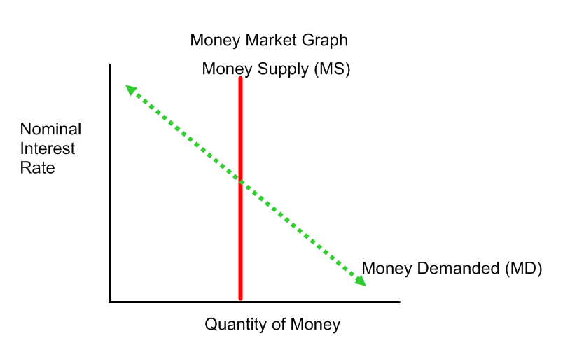
Money Market Graph: Measures how much money is in the banking system and the effects of changes to the money supply on nominal interest rates, quantity of money and money demanded.
1) Parameters:
a) Nominal Interest Rate: The interest rate not adjusted for inflation. It is the opportunity cost for holding money in the money market.
b) Quantity of Money: The amount of money in the economy.

2) Lines of the Graph:
Money Supply (MS) – the current supply of money in the economy. The Money Supply cannot change unless the Federal Reserve changes the amount of money in the banking system. The Money Supply shifts (increases or decreases) due to changes made by the Federal Reserve:

Tool | Description | To Increase Money Supply | To Decrease Money Supply
Change Reserve Requirement Ratio (RRR) | Change the percentage of each deposit that banks must hold aside. | Lower the reserve requirement ratio. | Raise the reserve requirement
Change the Discount Rate | Change the rate of interest the FED charges on bank borrowings | Lower the discount rate | Raise the discount rate
Open Market Operation (most used) | Buy or sell government securities in the secondary market. | Buy government securities | Sell government securities

- Money Demanded: This is the amount of money demanded from the banking system, which is inversely proportionate to the interest rates.
    - Money is demanded as a transaction demand (to buy goods), asset (to save), precautionary (liquidity), and speculative demand (to use money for financial investments). As one of these increases or decreases, money demanded will shift.
    - Money Demanded also has the ability to shift. Factors such as current price level, real income, unexpected expenses and real GDP all have a direct relationship to shifting money demanded (if one increases, money demanded shifts to the right and vice-versa). Expectations of future interest rates and expectations of inflation/economic downturn has an inverse relationship. Newer financial innovations (such as credit and debit cards) decrease the demand for money (because we physically need less cash).
- Based on this information and what we have learned about the banking system, why would the parameters for the graph by Nominal Interest Rate and Quantity of Money?

- How does the money supply shift?

- Identify the factors of shifting money demanded (current price level, real income, real GDP, expectations of future interest rates, expectations of inflation and newer financial innovations as either transaction, asset, precautionary, or speculative.
Part 2: How does the graph operate/play out when monetary policy occurs?

Part 2a)For Recession:
Fed increases the money supply, when this happens there is a greater availability of money, so banks will be more willing to take out loans, which will lead to a decrease in nominal interest rates. With interest rates lower, there is a movement along the demand curve showing an increases the quantity demanded for money. With more money being demanded, this will then increase borrowing, spending and investing, which then increase aggregate demand.

Federal Reserve Expansionary Monetary Policy (for recession) –
1) Results to money market/banking system.
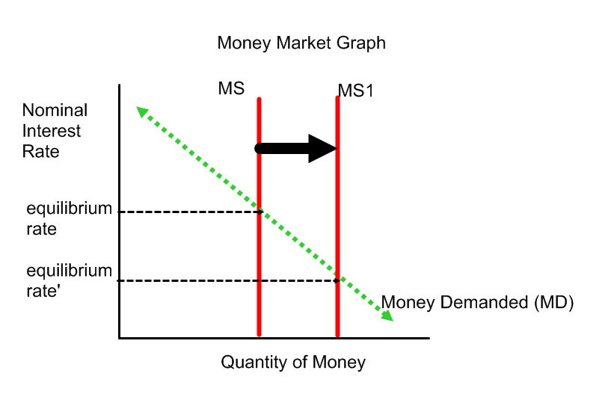
2) Results to overall economy
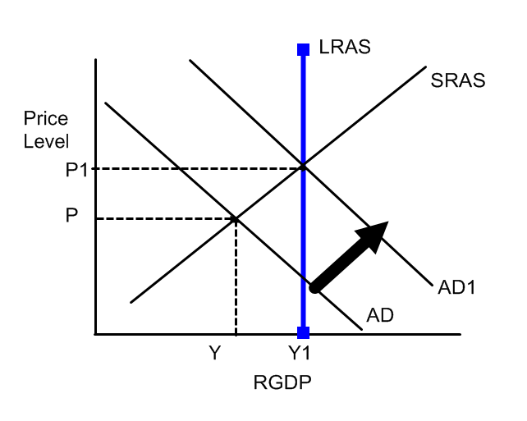 1) Describe in your own words, first, what happens to the money market and why, and then what happens to the overall economy and why.

2) How do the two graphs work together?

Part 2b) For Inflation:
Fed decreases money supply. With less money circulating in the banking system, banks will raise the Federal Funds Rate, which raises the nominal interest rate because they will be more hesitant to lend out money, with less on hand. This increase in the nominal interest rate decreases the quantity demanded for money because people/businesses will not want to borrow at the much higher rate and consumers would rather keep their money in savings accounts to earn interest. This decrease for the demand for money then decreases borrowing, spending, investing which decreases aggregate demand.
Federal Reserve Contractionary Monetary Policy (for inflation)
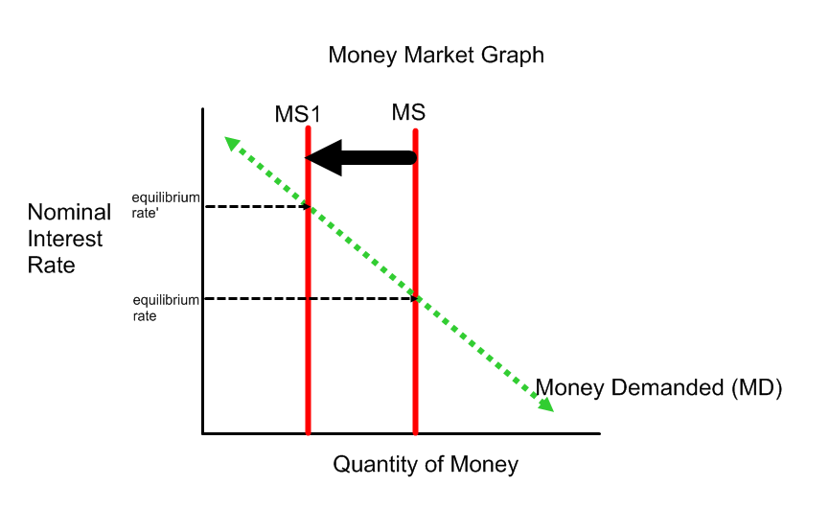
Result to Economy
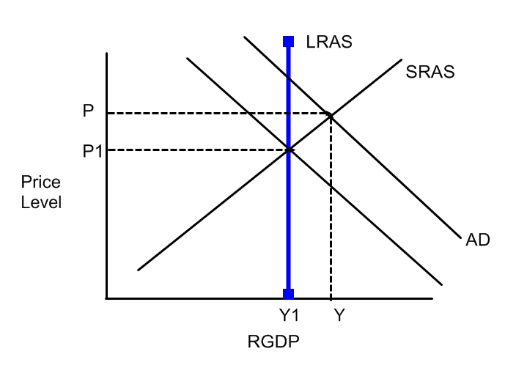
1) Describe in your own words, first, what happens to the money market and why, and then what happens to the overall economy and why.

2) How do the two graphs work together?

3) Why is it important for the government and Federal Reserve to work together with Fiscal and Monetary Policy?

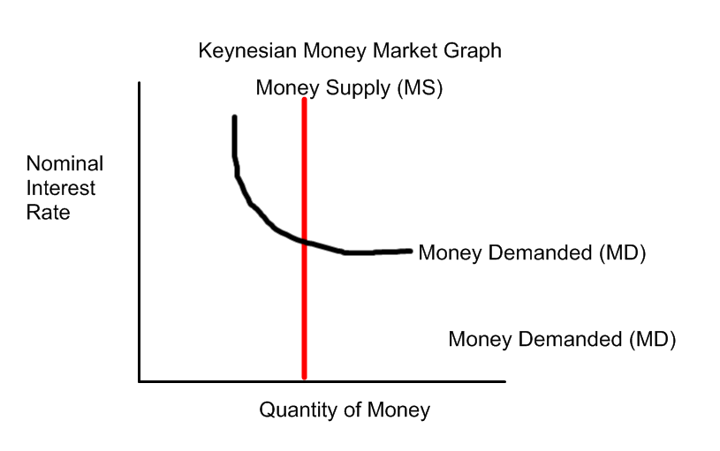
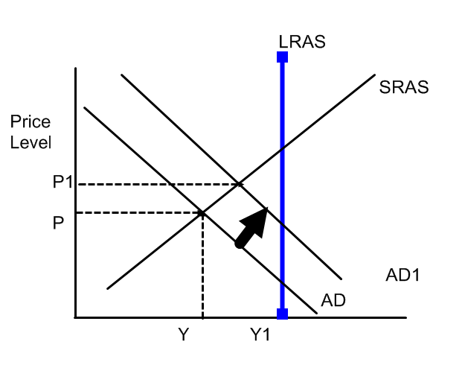
The Keynsian Money Market Graph has a much smaller slope than the Monetarist view because
Keynes believes that monetary supply has less of an effect then fiscal policy. Keynesian economists believe that the price level is sticky (prices and wages do not adjust quickly), so monetary policy will not have as great of an effect as direct government spending. Keynes also believes in the neutrality of money or quantity theory of money, meaning that an increase in the money supply will primarily increase prices, but not output in the long run.
Therefore, according to Keynes, when AD is shift due to monetary policy, it will actually be less than a shift due to fiscal policy.

- Why does Keynes create a different money market graph? Do you agree/disagree with his interpretation?

