Aim: What are exchange rates?
Topic: Exchange rates?

Document #1: Introduction to Exchange Rates
Part I: What are exchange rates?
Exchange Rates: Exchange rate is the value of one country’s currency in terms of another country’s currency OR how much it takes of one country’s currency to buy 1 dollar of another country’s currency OR how much 1 dollar of one country’s currency can buy of another country’s currency. .

Part II: Exchange Rate value:
If it costs more of currency y to buy 1 dollar of currency x or 1 dollar of currency x can buy more units of currency y; then currency has a greater value or is appreciated against currency y. Currency y has a smaller value or is depreciated against currency x.

Part III: How do currencies change value?
Currencies change value relative to each other based on the Supply and Demand of the currencies in relation to each other.
Remember, if you buy something from another country, you are going to need their currency. This affects the demand of their currency. However in order to get their currency, you have to supply your own currency.

For Example:
U.S. imports or spending abroad requires a demand for foreign currency and a supply of U.S. dollars (to buy that foreign currency)

U.S. exports (and foreigners spending money in U.S. markets) require a supply of foreign currency (to buy U.S. dollars) and a demand for U.S. dollars.

The currency in demand appreciates (becomes more valuable/stronger)
If a currency that is supplied depreciates (becomes weaker/less valuable)

Part IV: What affects Demand?:
  - Demand for a nation’s exports
  - Relative interest rates
    - People would want to put their money into a nation’s banking system with the higher interest rate vs. a nation with a lower interest rate.
  - Political/Economics stability
    - A strong/growing economy will encourage foreign direct investment (money coming into the country to build factories or buy businesses.
  - Relative level of income/RGDP
    - An increase in income/RGDP would increase our demand for other nation’s products
    - A decrease in income/RGDP relative to another nation would decrease our spending ability and increase our exports and demand for our currency.
  - Relative prices (theory of purchasing power) and Price Stability
    - If products are more expensive here, domestic consumers will look elsewhere (import more from foreign nations). However if the domestic dollar has a good purchasing power, foreigners will demand our products.
  - Speculation
    - Speculating that a currency will appreciate in value which would allow you to reconvert it into your currency for a profit.
  - Fiscal and Monetary Policy
    - Expansionary Fiscal Policy increases income/RGDP and price level which all tend to drive imports and demand for another country’s currency
    - Contractionary Fiscal Policy that decreases income/RGDP and price level discourage spending abroad and make domestic products more attractive; increasing the demand for the domestic nation’s currency
    - Deficit Spending can raise the real interest rate, which makes people want to put their money into a nation’s banking system with the higher interest rate.
    - Expansionary Monetary Policy decreases interest rates relative between nations and would make the domestic nation’s banking system less attractive as compared to the foreign.
    - Contractionary Monetary Policy raises a nation’s interest rates and people would want to put their money into a nation’s banking system with the higher interest rate vs. a nation with a lower interest rate.

Capital Inflow and Outflow:
An increase in money into the banking system from foreign investors is called Capital Inflow and will increase the supply of loanable funds and lower the interest rate.
Money leaving the banking system into another banking system would represent a Capital Outflow and will decrease the supply of loanable funds and raise the interest rate.

Document #2: Graphical Representation and the Exchange Rate Graph:
Foreign Exchange Market Graph
The Foreign Exchange Market Graph is a supply and demand graph for the domestic currency. 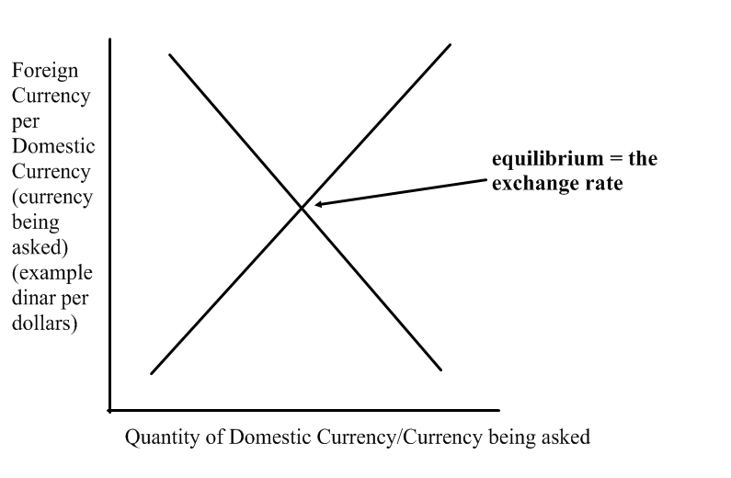
The Demand Curve represents The Demand For the Currency which is created by foreign demand for U.S. exports, foreign demand for U.S. investments, speculation, etc. On the demand side, the foreigners are initiating the exchanges (demand for our currency is increasing).
The Supply Curve represents The Supply of Currency which arises from similar sources. On the supply side, it is the domestic nation which is initiating the exchanges (supply of our currency is increasing to buy foreign products).
- Supply and Demand
  - remember the difference between change of (shift of curve) and change in quantity of (movement along a curve)
  - Supply and Demand for two different countries.
    - When comparing two countries, we need to create two different exchange rate graphs – each in terms of the two countries’ currencies.
    - If the demand for the currency of country A increases, then country B’s supply of their own currency will have to increase in order to buy more of country A’s currency.
In the following example, we are demanding German products so we must supply US dollars to buy euros.
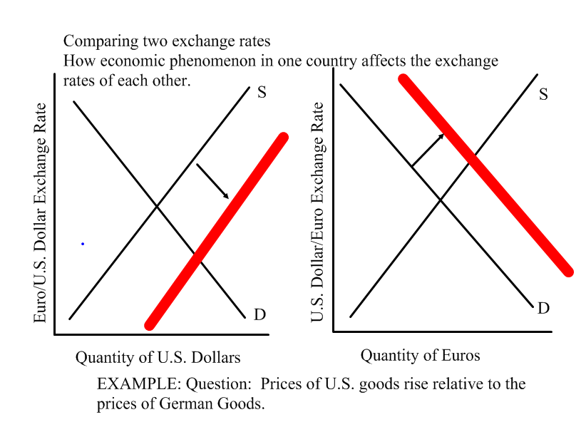
In this example, American citizens wanted to buy German goods. In order to do so, the Americans initiated the exchange buy supplying USD in the foreign exchange market. This increase in Supply depreciated the USD against the Euro. The Americans then used the supplied USD to exchange for (demand) euros. This increase in demand appreciated the euro.

Document #3: Is it better to have an appreciated or depreciated currency?
What’s good and bad about appreciating?
- An appreciated currency allows the domestic dollar to go further in purchasing imports, businesses investing in foreign capital goods and for tourists traveling abroad, but hurts domestic tourist industries.
- An appreciated currency moves the balance of trade toward deficit as imports are greater than exports.

What is good and bad about depreciation?
- Depreciated currencies have a favorable balance of trade (exports are greater than imports and the balance of trade moves toward a trade surplus) and strong tourist industries but is harder for its citizens to import products, travel and for businesses to invest in foreign capital.

Document #4: The role of central banks:
Central Banks and the Treasury Account (from the Balance of Accounts) help to oversee and manage exchange rates.
1) Central Banks can permit a flexible exchange rate that changes with demand this is called floating currency (this allows a more circular value: currencies appreciate, then depreciate, then appreciate again, and so forth based on trade and value).
2) Central banks have the power to fix or manage exchange rates. In this case if a nation wants to keep its currency depreciated it can supply its currency to buy (demand) foreign currency or sell foreign currency to appreciate its currency. The central bank can also create the appropriate monetary policy to raise or lower interest rates to increase/decrease demand for its currencies.

Study Questions:
- Why are currency values determined by the comparative supply and demand of two currencies?

- How can currency values affect the balance of trade?

- Is it better to have an appreciated or depreciated currency?

- Should nations and central banks allow their currency to float or try to fix/manipulate their currency?

