Aim#8 – How do societies make decisions regarding production?
Topic: Opportunity Costs in society

Trade-offs: These are the two choices - one of which we give up.

Opportunity Costs: This is what we are giving up/losing when you trade-off.
*Economists measure choices in terms of opportunity cost, or what is being lost/given up when you produce the good/service you chose.
How many units of product B will be sacrificed to produce product A?

example: nation has two trade-offs: produces war goods or educational products. If the nation chooses to produce war goods, the opportunity cost would be educational products.

Opportunity Cost:
There are two different formulas for opportunity Cost.
1) The most basic formula is determining the opportunity cost of goods being produced:

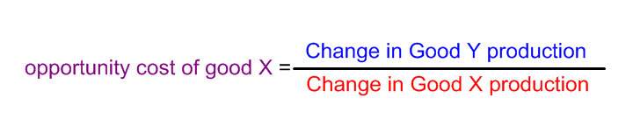

2) There is also the opportunity cost of time spent producing that chosen activity, which is set up THE OPPOSITE WAY.
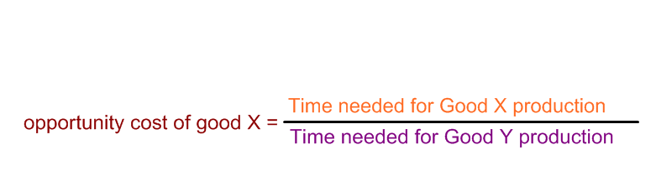

Concept #2 -- Law of Increasing Costs
The law of increasing costs states that as more of a product is produced, the opportunity cost increases. This is because resources are not being properly allocated or allocated in the most efficient manner possibly as more resources are diverted from one product to the other.
(example, choosing to produce war weapons over educational resources: the people/resources needed, don’t exactly match up, and the strain of production increases).
*This is represented in the Production Possibilities Curve as a concave (curved) line facing away from the origin (0-0).
*Sometimes the opportunity costs decrease (if the two industries are well related) and the curve is concave toward the origin.

Concept #3: Production Possibilities Curve/Frontier
The production possibilities curve is a graphical representation of the country’s ability to produce certain goods as well as of its opportunity cost for producing those goods.
The Production Possibilities Frontier assumes:
1. That all resources (factors of production) are fully employed
2. Technology (capital) is constant
3. Quality of resources is constant
*You can use the Opportunity Cost to plot the points on the graph, as the answer gives you the slope (rise over run).
*A production possibilities curve that is a straight line, means that there is a constant opportunity cost – the opportunity cost remains the same throughout the amount of increased production and units given up.

PPC/PPF: shows the production of a country. All points along the line show that the country is maximizing the use of its resources.

*Points inside the production possibilities frontier:
A nation is not utilizing its resources in the fullest/most efficient way possible.

*Points outside the production possibilities frontier:
Unobtainable with the country’s current factors of production.

*Factors that influence a countries production possibilities frontier:
a) changes in the amount of resources/factors of production in the economy
b) changes in technology
c) changes in productivity

*When one of these occurs, for better or for worse there is a shift in the PPC.
*shift to the right - always shows an increase
*shift to the left - always shows a decrease

