Aim: What are the limits of fiscal and monetary policy?
Topic: Phillips Curve

Part 1: Short-Run Phillips Curve
The Phillips Curve or Short-Run Phillips Curve was created by A.W. Philips. It shows the relationship between the unemployment rate and the rate at which wages change (inflation rate). He discovered that the changes in wages were inversely related to the unemployment rate. Subsequent research showed the same relationship between inflation and unemployment. This is known as the Phillips Trade-off: government policies that decrease inflation, reduce output which increases unemployment; and when the government uses polices that decrease unemployment, it raises prices which increase inflation. However, the trade-off is a short-run phenomenon.
1) When the government creates policies to decrease inflation, how does it affect output and unemployment? Why?

2) When the government creates policies to decrease unemployment, how does it affect inflation? Why?

3) Based on the first two answers, how is one an opportunity cost of the other?

Part 2: Graphical Representation of the Short Run Phillips Curve
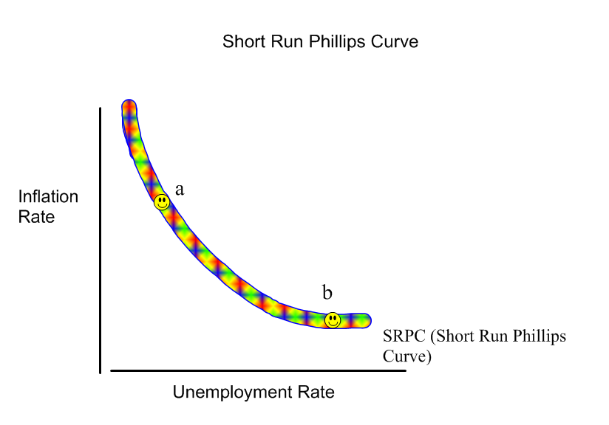

Parameters of Phillips Curve:
a) Inflation Rate/Expected Inflation Rate
b) Unemployment Rate
c) Expected Inflation Rate and the natural rate of unemployment are constant.

Shifts in Aggregate Demand create movements along the Phillips Curve.
Increase in Agg. Demand (AD shifts Right on AS/AD graph) : Movement to the left on Phillips Curve (from b to a) – increase in inflation rate, but decrease in unemployment rate.
Decrease in Agg. Demand (AD shifts to the Left on AS/AD graph): Movement to the right on Phillips Curve (from a to b) – decrease in inflation rate, but increase in unemployment.
Remember: Fiscal and Monetary Policy as well as other economic phenomenon can all increase and decrease (shift) AD which then create movements along the Phillips Curve.
1) Why are the two graph parameters the inflation rate and the unemployment rate?

2) Why do increases in AD create a leftward movement on the Phillips curve (from b to a)?

3) Why do decreases in AD create a rightward movement on the Phillips curve (from a to b)?

Part 3: Shifts in Aggregate Supply create shifts of the Phillips Curve
We discussed shifts of aggregate demand, but what about shifts of aggregate supply. Remember – Aggregate supply represents the ability and willingness of suppliers to produce. This is affected by both input costs and expectations of inflation.
Aggregate supply curve shifts right: shift to the Left on Phillips Curve (decreases inflation and unemployment).
Aggregate Supply curve shifts left: shift to the Right on Phillips Curve (increase in input costs)creates more unemployment and raises prices).
This phenomenon is known as Stagflation – when the economy is suffering from inflation AND unemployment. This defies the Phillips relationship which concludes that unemployment and inflation move in opposite directions. However, because of the Phillips Trade-off, this highlights why making government policy to combat stagflation is makes government policy very difficult: solving one problem creates the other problem.
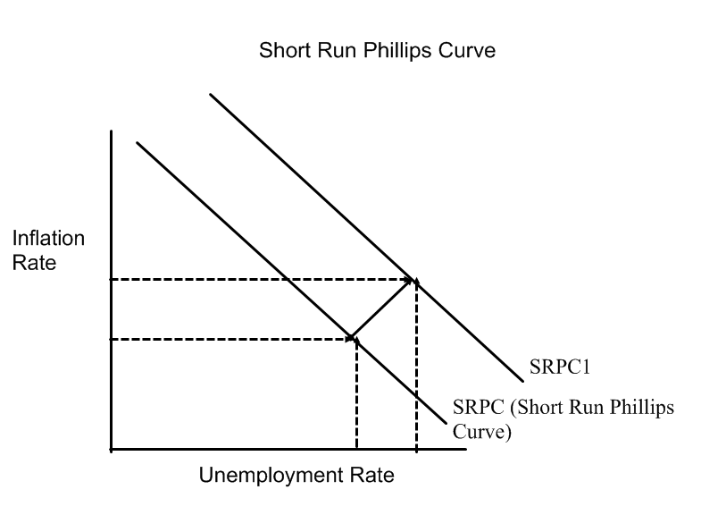

The solution to stagflation?
Only new resources/technology can shift both SRAS and LRAS, but if the government was to do something, then it should focus on supply-side economics: Special fiscal tax policies and reduction of government regulations that encourages the expansion/creation of resources and business’s ability to produce and reduce input costs (thus shifting the aggregate supply curve to the right).
When a change in supply causes a shift in the SRPC to the right, notice how both the inflation rate increased and the unemployment rate increased.

1) When supply shifts why does it shift the entire SRPC line?

2) When supply shifts to the left, why does the SRPC shift to the right?

3) When supply shifts to the right, why does SRPC shift to the left?

4) What is stagflation?

5) How does the Phillips Curve illustrate the problem with trying to use Demand-Side economics to solve stagflation?

Part 4: Other Shifts of the Phillips Curve: Expectations of Inflation:
When people expect inflation, the Phillips Curve will shift right because workers and firms build these expectations into their wage and price contracts, and these higher wages and prices result in inflation. Expectations of inflation thus increase inflation for any level of unemployment (and may in fact create more unemployment from layoffs). If prices are expected to rise more slowly (or decrease) in the future, inflation will decrease for any given unemployment rate and the Phillips Curve will shift to the left.
1) How do expectations of inflation shift the Phillips Curve?

Part 5: Long Run Phillips Curve/Natural Rate of Unemployment
Remember, the natural rate of unemployment is where cyclical unemployment is 0% yet frictional and structural unemployment can still exist. In the AS/AD graph, this is also known as Long Run Aggregate Supply and is represented as a vertical line. This is also represented on the Phillips Curve as the Long Run Phillips Curve/Natural Rate of Unemployment.
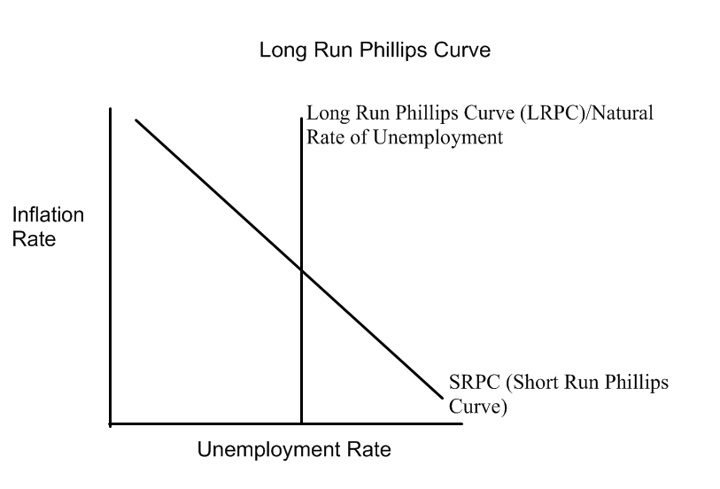
Sometimes the AP Test will ask you to label the natural rate of unemployment at 4% on a Phillips Curve. Just draw the LRPC and write 4% on the bottom. You will notice that as AD shifts cause movements on the SRPC, how the economy moves away from the Natural Rate of Unemployment. When LRAS shifts, so, too, will the LRPC.
1) What is the LRPC/natural rate of unemployment?

2) How are the LRPC and LRAS related?

3) What happens to the LRPC when LRAS shifts? Why?

Review Questions:
1) One drawback of using fiscal policy to close a recessionary gap is that
a) unemployment will rise
b) taxes will have to be raised
c) the equilibrium price level will rise
d) government spending on important programs will have to be cut
e) equilibrium output will fall

2) Stagflation occurs when
a) inflation falls and unemployment rises
b) inflation rises and unemployment falls
c) inflation and unemployment both rise
d) inflation and output both rise
e) inflation and output both fall

3) The Phillips Curve
a) shows how the government spending and tax collections are related
b) is upward sloping from left to right
c) indicates that inflation will be high when unemployment is low
d) shows how the equilibrium price level is related to fiscal policy
e) shows how output and prices are related.

4) Which of the following statements would “supply side” economists disagree with?
a) tax changes cause shifts in aggregate supply that work against shifts in aggregate demand, thus reducing the effect of the tax change on real GDP
b) A tax cut is likely to increase aggregate supply by boosting saving, investment and thus capital accumulation
c) A tax increase is likely to decrease aggregate supply by decreasing after-tax wages and thus providing disincentives to work.
d) a tax cut is likely to increase aggregate supply by providing greater rewards for risk taking.
e) a decrease in tax rates does not necessarily result in a decrease in tax revenues.

5) Free Response Question:
a) Draw a Phillips Curve. Be sure to label the axes of your diagram.
b) Draw a point on the Phillips curve that shows a recession – label it “R”.
c) Suppose a fiscal policy is implemented and this policy closes the recessionary gap. Mark and label another point on the Phillips curve to show the new inflation/unemployment combination and label it “AFP” for “After the Fiscal Policy.” Explain how you concluded where AFP would be.
d) Draw a natural rate of unemployment of 4% and label it
e) If there was an oil embargo against America, draw the results on this Phillips graph. Explain what happened

