Instructions:
Read Part I and identify:
One Social Cause of the Reformation:
One Political Cause of the Reformation:
One Economic Cause of the Reformation:

Read Part II and identify:
Two Social Impacts of the Reformation:
Two Political Impacts of the Reformation:
Two Economic Impacts of the Reformation:

Read the Part III Documents and answer the questions underneath each document

Write a TEAL paragraph in which you evaluate the impact of the Reformation as a turning point in world history. Make sure you use two specific impacts and one document from Part III in your answer.

Identify and explain. three enduring issues from Part I, II and III.

Part I: Historical Circumstances and Context of the Reformation
By the 1500s, many Christians wanted to reform the Church. The new Renaissance values of questioning and rationality led people to question the authority, power and practices of the Church. As ordinary people examined the Church, some felt that its leaders were acting more like kings, fighting for power and wealth, than like representatives of God. Others objected to the Church charging increased fees for marriages and baptisms and selling indulgences, or pardons for sins. One such person was the German monk Martin Luther. Disgusted over the sale of indulgences (selling forgiveness), Martin Luther took action in 1517. He posted his famous 95 Theses, which were 95 arguments against indulgences, on the door of a church in Wittenberg. This event sparked the Protestant Reformation, the period when Europeans broke away from the Catholic Church and formed new Christian churches.
Luther believed that people could reach heaven only through faith in God and that the pope could not grant a pardon for sins. He thought that the Bible was the only source of religious truth. Luther was excommunicated, or excluded from the Roman Catholic Church, for his radical views. The ideas of Luther, however, spread throughout northern Europe and Scandinavia, thanks in part to the printing press; which was able to print his 95 Thesis and versions of the Bible for everyone to read. He also had help from the German lords and princes who saw this as an opportunity to be their own strong ruler, and not be under the power of the Church or its taxes (tithes). Followers of Luther’s beliefs were called Lutherans and—eventually – Protestants because they protested papal authority.
John Calvin was another influential reformer. Born in France, Calvin was trained as a lawyer. Like Luther, Calvin believed that Christians could reach heaven only through faith in God. Calvin, however, had his own views on the power of God and the nature of human beings. He promoted the idea of predestination, the belief that God had determined before the beginning of time who would gain salvation. Calvin’s followers lived strict, disciplined, and frugal lives. Calvinism spread to Germany, France, Scotland, and England.

Part II Impacts of the Reformation
The Reformation created a loss of religious unity in Western Europe. Political divisions resulted as well. Rulers often chose a religion for their nations (such as when Henry VIII made a new Anglican Church and made it the new official Church of England). While some states remained Catholic, others became Protestant. For more than 100 years after the Reformation, wars sparked by religion raged in Europe. In the 1500s, religious civil wars occurred in Germany and France, and Spanish Catholics battled English Protestants. The Thirty Years’ War, involving many European states, occurred in the 1600s. The Jewish people were often caught in the middle of these wars. They were expelled from their homes into different neighborhoods, persecuted with unfair laws and even murdered. Religious fervor sometimes led people to accuse others of being witches, agents of the devil. Thousands of people, especially women, were put to death for this reason. Peasants also saw all of this religious change as a chance to demand change to their living and economic conditions and peasants revolted all over Germany and Central Europe.
As the Roman Catholic Church began losing more and more power, in 1545 Pope Paul III called for the Council of Trent to begin the Counter Reformation. The goals of this series of meetings was to both stop the spread of the Protestant Reformation and to strengthen and reform the Catholic Church. Although the Protestant Reformation continued to spread, a reform movement was also taking place within the Roman Catholic Church. The
The Council of Trent ended the sale of indulgences, created a list of banned books (known as the Index), created an order of missionaries to spread Catholicism and created the Inquisition to end the spread of the Reformation. Ignatius Loyola founded the Society of Jesus, also called the Jesuits. The Jesuits are a religious order that emphasizes spiritual and moral discipline as well as strict obedience to Catholic authority. Early Jesuits saw themselves as the defenders of the Catholic faith throughout the world. Many Jesuits became advisors to Catholic rulers. Jesuit missionaries spread Catholicism to Asia, Africa, and the Americas. The Church used a court made up of Church officials to root out heresy by force, known as The Inquisition. Trials were held, often using torture, to find people suspected of having beliefs that differed from official Church teachings. Although the Counter Reformation did help to stop the spread of the Protestant Reformation and spread Catholicism around the world, the world was also forever changed and would not return to the days where the Roman Catholic Church was the dominant religious and political force in Europe.

Part III: Document Analysis

Document #1: Martin Luther’s 95 Thesis Excerpts, 1917
#2 “Paying money to the Church for forgiveness is not the same as praying to God, or confessing to a Priest”
#32 “Those who believe that they can be certain of their salvation because they have indulgence letters will be eternally damned, together with [the people who sold the indulgences]”
#37 “Any true Christian, whether living or dead, participates in all the blessings of Christ and the church; and this is granted him by God, even without indulgences letters…”
#43 “Christians are to be taught that he who gives to the poor or lends to the needy does a better deed than he who buys indulgences…”
1) What is Martin Luther’s purpose of writing this document?

2) According to this document, what is Martin Luther’s point of view on Church practices?

Source#2: A German Prince on if his people should join Martin Luther, 1517
We see there is no gold, and almost no silver in our German land. What little there is left is taken away by the Church in Rome. Would you know, dear German, what they do with our money? It does not lie idle! Leo the Tenth gives part to his nephews, relatives, cardinals, secretaries, and other officials. They build marble homes. They have precious stones, are clothed in purple and fine linen, and live in luxury. In short, a vast number of the worst of men are supported in Rome in idle life by means of our money.”
1) According to this document, what are the historical circumstances why the German nobility would support Martin Luther?

Source #3: Alfonso de Valdes; a Catholic responder on Martin Luther and the spread of Protestantism, 1518
Luther, relying upon The Duke of Saxony’s protection, wrote and published new attacks on the Catholic faith. The Pope launched a most severe bull against Luther and his supporters. Then Luther proclaimed the Pope himself a heretic. Not content with this, he publicly burned all the books on Church law he could find in Wittenberg. The report of these events, spread throughout all Germany, stirred up the Germans against
Rome. If the Pope does not come to the relief of these evils, I fear, and I do very much fear, that this evil will spread so widely as to be absolutely incurable. Many of the German rulers also welcomed Luther’s views. They hoped they might bring an end to the Church taking wealth from lands to spend it in Rome. Luther appealed to them in a leaflet called To the Christian Nobility of the German Nation. He urged them to make the church truly German. He wanted it to be independent of Rome.
1) According to Alfonso de Valdes, what has been the impact of Martin Luther’s ideas on Europe?

2) According to Alfonso de Valdes, what is his point of view on Luther?

Document #4
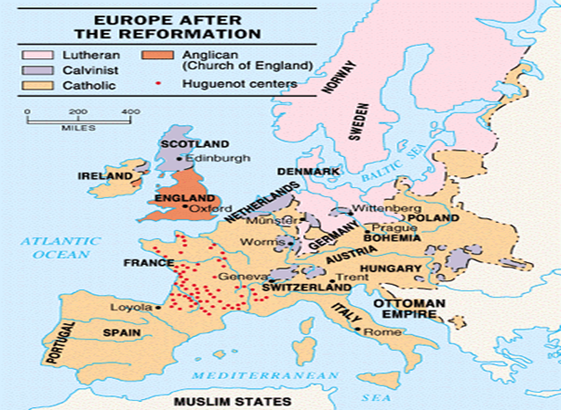

1) How does the map illustrate the impact of Luther’s ideas and the Protestant Reformation?

Source #5: Martin Luther (Diet of Worms 1521), on being told to recant (take back what he said) or be executed)
“Unless I am proven wrong by the Bible and by plain reason, I cannot and I will not go back on anything, here I stand. I can do no other. God help me. Amen.”
1) What is Luther’s point of view of his ideas?

