Homework #10 - World War I (1914-1919) Overview

During the turn of the 20th century, America became stronger from its imperialist and expansionist policies. Many people in the U.S. supported these actions because it made the US strong since the country now had more places to sell goods. However, as America became stronger, it also got more involved in European affairs (just as Washington warned about in his Farewell Address!) In 1914, the Alliances of Great Britain, France and Russia (Triple Entente) went to war against Germany, Austria-Hungary and the Ottoman Empire (Triple Alliance). During 1914-1917, despite the efforts of President Woodrow Wilson, the U.S. was slowly pulled into World War I with the Zimmerman Telegram, Sinking of the Lusitania and Russian Revolution. The U.S. began selling weapons to the more democratic countries of Britain and France as they fought against the more autocratic (rule of one person) governments of the Triple Alliance. Eventually U.S. civilians became victims, as German unrestricted submarine warfare sank the cruise ship the Lusitania. Germany claimed that the Lusitania was secretly transporting weapons and ammunition from the U.S. to Britain. In 1917, after Wilson’s reelection and the Russian Revolution put Russia out of the war, America joined the war on Britain and France’s side in 1917. With fresh soldiers, the Triple Entente won and in 1919, Germany surrendered.
Wilson was determined to create a lasting peace, with America at the lead. He believed that the United States had a democracy to protect and spread democracies, self-determination and the freedoms of peoples around the world. Wilson’s 14-Points tried to create a post-WWI world with no alliances, no military build-up, no colonialism and self-determination by all nations (nations should be independent) as well as an international peace keeping organization known as The League of Nations. The Europeans however, wanted to punish Germany and only kept The League of Nations in the final peace treaty, The Treaty of Versailles. However, after the war the Senate (which ratifies (approves) all treaties) did not want to sign the Treaty of Versailles because of the League of Nations and wanted to follow a policy of isolationism – not getting involved in foreign affairs. The U.S. isolated itself from the Europeans. U.S. isolationism would last until the U.S. entered World War II in 1941.
The war’s greatest significance might have actually been felt on the home front, though. At home, the war changed America; the important Supreme Court case Schenk v. U.S. limited freedom of speech during times of war. The Supreme Court ruled that speech or actions that creates a clear and present danger (such as “shouting fire in a crowded theatre”) are not protected by the Constitution. However, rights were also gained. While the men were away fighting, women worked in factories – their work at home helped America send millions of men overseas and win the war. The government rewarded the sacrifice of women and finally gave them the right to vote with the ratification of the new 19th Amendment.

Instructions: Write down the vocabulary words and definitions. Answer the study questions in your regents study book/ binder.
Unit Vocabulary Words
1) President Woodrow Wilson -tried to keep the U.S. out of W.W.I, but was forced to after the Sinking of the Lusitania, Zimmerman Telegram and Russian Revolution put Russia out of the war. He was also the creator of the 14 Point Plan for peace and the League of Nations.
2) Lusitania – American cruise ship that was sunk by German U-Boats (submarines) for suspicion of carrying supplies to England. Many wanted war with Germany because of this.
3) Unrestricted submarine warfare - Germany's plan to attack all non German ships. The need to protect its military and commercial ships pushed the US government to enter WWl.
4) Zimmerman Telegram – Letter from Germany to Mexico that supposedly said that Germany wanted Mexico to attack America. Many wanted war with Germany because of this.
5) Russian Revolution – When the people of Russia overthrew the Tsar and Russia exited the war. America had to join England and France or they would lose.
6) 14 Point Plan- Wilson’s plan for after the war that would create world peace. It called for self-determination of colonized nations, no alliances and decrease size of militaries and the creation of a League of Nations.
7) League Of Nations - an organization that promoted world cooperation and peace. However, since the U.S. did not join, and the League did not have the power to prevent World War II. The League of Nations is the first try/original version of the current United Nations.
8) Treaty of Versailles (1919) - blamed and punished Germany for starting World War I and created a League of Nations.
9) Isolationism – a foreign policy of not getting involved in foreign affairs
10) Foreign Policy – Relations/actions towards other countries.
11) Farewell Address – Washington’s Farewell letter to the nation (1796) that recommend a foreign policy of isolationism
12) Schenk v. U.S. (1919) - The U.S. Supreme Court decided that the government can limit freedom of speech during wartime if the speech/actions represent a clear and present danger such as “shouting fire in a crowded theater.”
13) 19th Amendment – This gave women the right to vote. It was created after they worked in factories for men on the home front during World War I.
14) Ratify – to approve
15) Home front -- how the war affects life at home.
16) Self Determination – nations should not be under colonial rule, but should be independent.
17) Cause and effect – Cause is the reason an event starts. Effect is the reaction to the cause.
18) War Bonds – When the government sells bonds (assets/securities) to raise money now for the war and then pay the people who bought them back for a greater amount later.

Part II: Study Questions Look at the documents below and answer the following question in one full T.E.A.L. paragraph each (5-7 sentences, with evidence and analysis from EACH document, along with your knowledge of history in each paragraph)

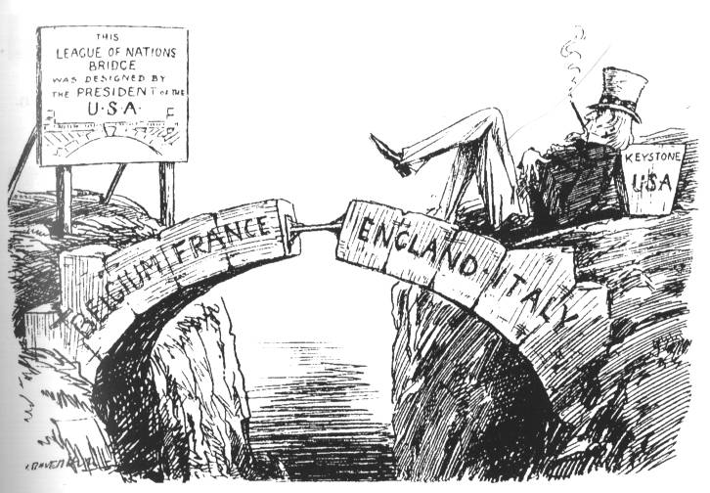
Document #1: League of Nation’s Bridge Document #2: “Interrupting the Ceremony”
“If Any Man Can Show Just Cause, why they may not lawfully be joined together, let him speak now . . . “

- Describe the historical circumstances that led to the creation of each of these documents

- Describe each author’s point of view on American foreign policy after World War I. Which viewpoint do you agree with? Why?

Rubric | 5: Excellent work. | 3: Acceptable work. | 1: Not Acceptable
TASK | All aspects of the task are addressed evenly and in depth. | Most aspects of the task are addressed; or all aspects are addressed, but somewhat unevenly. | Essay is very uneven and/or addresses only a portion of the task.
EVIDENCE | Richly supports the theme with many (2-4) relevant facts, examples, and details. | Includes some (1-2) relevant facts, examples, and details; may include some inaccuracies. | Includes little or no relevant facts, examples, and/or has many inaccuracies.
ANALYSIS | Clearly demonstrates analysis well beyond description. Rich Analysis: evaluates the impact, change, extent of effectiveness for all aspects of the task. | Demonstrates some analysis but is mostly description. Some Analysis: discusses the impact, change, extent of effectiveness for some of the task. | Demonstrates some description and lacks analysis. Lacks analysis of the impact, change, or extent of effectiveness for all aspects of the task.
ORGANI  ZATION | Intro includes strong historical context with a clear, concise thesis.  Paragraphs start with a clear topic sentence. | Intro includes some historical context with a thesis.  Paragraphs start with a topic sentence. | Intro lacks relevant historical context and lacks a thesis statement.  Paragraphs lack a topic sentence.

