Extra Credit HW Unit #10
Article: Wilson Urges Support for the League of Nations
Assignment:
- Answer in 2-3 sentences: What is the historical context of Wilson’s nation-wide push for the League of Nations?
- Answer in 2-3 sentences: Why do you think Wilson did not want to compromise on the Treaty? Why did the Senate ultimately vote against the Treaty?
- Answer in one T.E.A.L. paragraph: How did World War I impact the election of 1920? Why do you think people overwhelmingly chose Harding over Cox? Explain.
After the end of World War One, President Woodrow Wilson sought national support for his idea of a League of Nations. He took his appeal directly to the American people in the summer of 1919.
The plan for the League of Nations was part of the peace treaty that ended World War One. By law, the United States Senate would have to vote on the treaty. President Wilson believed the Senate would have to approve it if the American people demanded it. So he went to the people for support.
For almost a month, Wilson traveled across America. He stopped in many places to speak about the need for the League of Nations. He said the league was the only hope for world peace. It was the only way to prevent another world war. Wilson's health grew worse during the long journey across the country. He became increasingly weak and suffered from severe headaches. In Witchita, Kansas, he had a small stroke. A blood vessel burst inside his brain. He was forced to return to Washington.
The president's advisers kept his condition secret from almost everyone. They told reporters only that Wilson was suffering from a nervous breakdown. The Senate was completing debate on the Treaty of Versailles. That was the World War One peace agreement that contained Wilson's plan for the league. It seemed clear the Senate would reject the treaty. Too many Senators feared the United States would lose some of its independence and freedom if it joined the league.
The leader of Wilson's political party in the Senate, Gilbert Hitchcock, headed the administration campaign to win support for the treaty. Hitchcock told the president the situation was hopeless. He said the Senate would not approve the treaty unless several changes were made to protect American independence. If the president accepted the changes, then the treaty might pass.
Wilson refused. He would accept no compromise. He said the treaty must be approved as written. The treaty was defeated. From his sick bed, he wrote a letter to the other members of the Democratic Party. He urged them to continue debate on the League of Nations. He said a majority of Americans wanted the treaty approved.
The Senate Foreign Relations Committee agreed to re-open discussion on the treaty. It searched yet again for a compromise. But, as before, Wilson refused. He was a proud man. Wilson's unwillingness to compromise helped kill the treaty once and for all. The Senate finally voted again, and the treaty was defeated by seven votes. The treaty was dead. Yet history would prove him correct, and the Second World War would be far more destructive than the first.
The debate over the Treaty of Versailles was the central issue in American politics during the end of Woodrow Wilson's administration. It also played a major part in the presidential election of nineteen twenty.
The two presidential candidates gave the American people a clear choice in the election of nineteen twenty. On one side was Democrat James Cox. He represented the dream of Woodrow Wilson. In this dream, the world would be at peace. And America would be a world leader that would fight for the freedom and human rights of people everywhere. On the other side was Republican Warren Harding. He represented an inward-looking America. It was an America that felt it had sacrificed enough for other people. Now it would deal with its own problems. Harding virtually ignored Cox and essentially campaigned against Wilson, calling for a return to "normalcy"; with an almost 4-to-1 spending advantage, he won a landslide victory.
Excerpt from William Harding campaign speech 1920: “The country needs less government in business, more business in government…America's present need is not heroics, but healing; not nostrums, but normalcy; not revolution, but restoration; not agitation, but adjustment; not surgery, but serenity; not the dramatic, but the dispassionate; not experiment, but equipoise; not submergence in internationality, but sustainment in triumphant nationality.”
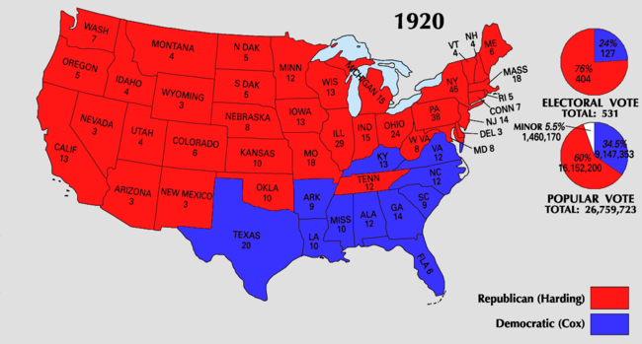
****Harding's victory remains the largest popular-vote percentage margin (60.3% to 34.1%) in Presidential elections after the victory of James Monroe in the election of 1820.

