Unit 11: The Roaring 20’s and American Prosperity
The Roaring Twenties was a very exciting time in U.S. History for many levels of society. Increased wages and decreased work hours made leisure and entertainment a very important part of American culture. Women, who now had the right to vote, went to college in greater numbers and experienced social freedom. They were much more independent, wearing skirts, smoking, drinking, dancing and became known as flappers. Both women and men enjoyed a new nightlife, listening to new jazz music. The widespread use of electricity greatly changed the American society and economy. New inventions such as the toaster, washing machine, and vacuum made life at home easier on housewives. Mass production of the automobile allowed more Americans the opportunity to travel within the country. There was also the birth of radio, television and movies. New personal finance practices such as advertising and using credit helped to increase consumerism. New developments such as radio and movies also increased and entertainment (including an increase in sports – especially baseball) became a very integral part of the 1920’s culture.
Presidents Warren Harding and Calvin Coolidge were presidents for most of the '20's. They believed in a return to normalcy (neutrality) and the business of America is business. Both presidents believed in the philosophies of capitalism – the use of capital (resources) to make profit, laissez-faire policy (the government should stay out of the economy), supply-side economics (the government should make taxes that support the growth of businesses. However, there was also one major scandal known as The Teapot Dome Scandal where the Harding Administration was caught selling oil rights to companies which violated American business practices. Due to their policies, the United States experienced great economic growth. Henry Ford developed the assembly line to mass produce cars. Cars as well as other luxury goods became more affordable.
The 1920’s was also a great time for African Americans. During the Great Migration African Americans moved from the South and Mid-West to Northern cities looking for job opportunities. Cities such as Chicago and New York City became centers for the growth of African American culture. This led to the Harlem Renaissance - when African Americans expressed themselves and pride in culture through art, literature, music, acting. They created jazz music and created the Apollo theatre where black artists and musicians performed.
However, the 1920’s was also controversial. There was much intolerance, especially towards immigrants (nativism). Nativism is usually caused by a fear of loss of jobs to immigrants and changing culture, but this nativism was also caused by a fear of communism. With the growth of Communism in Russia, Americans were scared of immigrants especially from Russia and Eastern Europe and America went through the “Red Scare.” Attorney General Palmer launched the “Palmer Raids” where the state department arrested and deported thousands of immigrants under suspicion of being communist. In the Sacco and Vanzetti Case, Italian immigrants Sacco and Vanzetti were sentenced to death because of an anti-immigrant jury. The Ku Klux Klan also had a rebirth, with hundreds of thousands joining in an effort to keep White American supremacy. Nativism resulted in several national immigration and quota (limitation) laws (such as the National Origins Act). People were also intolerant against the new evolution theory, and in a famous case, “The Scopes Monkey Trial,” the controversy was made public. Lastly, people became intolerant towards alcohol and pushed the government to pass the 18th Amendment – Prohibition – which banned the sale of alcohol. People violated these unpopular prohibition laws and it became common for people to drink alcohol illegally in places called speakeasies. With alcohol illegal, mafia crime lords such as Al Capone became rich by operating black market liquor sales. Prohibition was eventually appealed with the 21st Amendment, due to the inability to effectively regulate it.
The U.S., while we enjoyed exporting all of our new products, reverted (went back to) a policy of isolationism, rejecting President Wilson’s plan for the League of Nations; causing further division between Democrats and Republicans.

Flashcard Words
Part I. Copy the key terms and their definitions:
1) Roaring 20’s – A time of great prosperity in America
2) Flappers- name given to a new type of woman who smoked, drank, wore less restrictive clothing
3) Scopes "Monkey" Trial - the trial of a science teacher was fired for teaching Darwin's theory of evolution
4) Harlem Renaissance – Growth of African American culture.
5) Great Migration – When African Americans moved up from the South to the North.
6) Laissez-Faire – Policy of no government interference in the economy
7) Supply-side Economics – Government policies that help businesses grow
8) Capitalism – When Entrepreneurs use privately owned capital (resources) to create profit.
9) Prohibition- The 18th Amendment that banned the sale of alcohol. Unpopular and removed by the 21st Amendment.
10) Red Scare – When Americans were scared of immigrants and communist influence.
11) Palmer Raids – Attorney General Palmer’s “raids” to arrest and deport Russian immigrants due to fear from Communism spreading.
12) Scopes Monkey Trial – Court case which exposes the conflict over teaching evolution in classrooms
13) Assembly Line – Created by Henry Ford to mass produce cars and make goods more available and cheaper.
14) Henry Ford – Innovator of the “assembly line; a businessman who helped revolutionize producing and selling goods to people (especially cars – Ford Model-T)
15) Nativism: Fear of immigrants. Usually associated with fear of job loss to immigrants
16) Immigration/Quota Acts: Acts that set up quotas (maximum limits) for the amount of immigrants entering the country (such as the National Origins Act).
17) Sacco and Vanzetti Case – Two Italians were sentenced to death because of a prejudice jury.
18) Ku Klux Klan – organization whose agenda was to create a White Supremacist Society.
19) Intolerance – not accepting of other people.
20) Teapot Dome Scandal – When the Harding Administration was accused of selling oil rights to one company without a bidding by other companies.
21) Bootlegger: Someone who made and/or smuggled alcohol during Prohibition.
22) Speakeasy: Place where people went to illegally drink during Prohibition.
23) Al Capone: Mafia boss who ran illegal alcohol rings (networks) during Prohibition.
24) Presidents Warren Harding and Calvin Coolidge: Presidents from 1921-1929 who followed capitalist and free market ideas and policies of isolationism
25) Return to Normalcy – President Harding’s policy of remaining neutral in world affairs.
26) Consumerism – culture where people buy lots of consumer/household products and appliances
27) Credit – borrowing money to pay for your purchase and paying back the bank/company with interest.
28) Rugged Individualism – people and businesses should be individual and not look for the government for help and regulation.
Part II. Document Analysis and Study Questions:

Historical Context:
The 1920’s brought great social, economic and political changes within America. Some historians have said the 1920’s represent the birth of modern America with the growth of consumerism and a new middle class. However, there fear of the new threat emerging from the Bolshevik Revolution, that saw the success and growth of global communism. Americans feared communism would spread to America and undermine our robust capitalist economy and democracy. Fear of immigrants, especially from Eastern European nations and Russia grew, resulting in restrictions on immigration and growing nativism.

Task: Read the documents and then use at least two of the documents per study answer that follows. Answer each study question in at least one full T.E.A.L. paragraph.

Homework Question #1: How do the documents reflect the developments of the 1920’s, both as a time of progress and fear? differing points of view on the 1920’s; as both a time of progress yet also a time of intolerance?

Document #1: 1920’s Ford Model T Car Advertisement Document #2: 1920’s Hoover Vacuum Advertisement
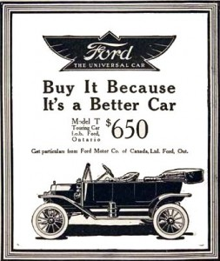
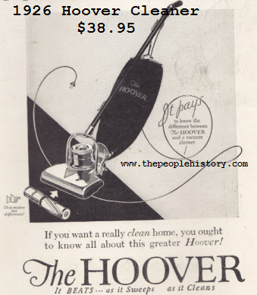

Document #3: “Close the Gate” Cartoon, Chicago Tribune, 1919
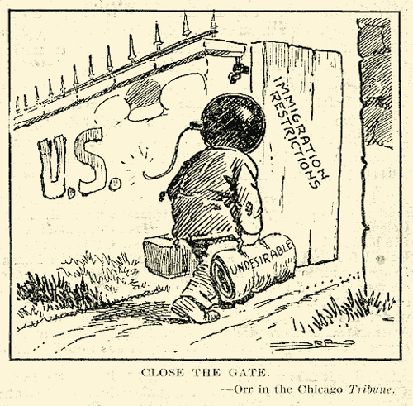

Document #4: Attorney General A. Mitchell Palmer, Excerpts from, “The Case Against the ‘Reds’,” 1920
“It has been impossible in so short a space to review the entire menace of the internal revolution in this country as I know it, but this may serve to arouse the American citizen to its reality, its danger, and the great need of united effort to stamp it out, under our feet, if needs be. It is being done. The Department of Justice will pursue the attack of these “Reds” upon the Government of the United States with vigilance, and no alien, advocating the overthrow of existing law and order in this country, shall escape arrest and prompt deportation. It is my belief that while they have stirred discontent in our midst, while they have caused irritating strikes, and while they have infected our social ideas with the disease of their own minds and their unclean morals we can get rid of them and not until we have done so shall we have removed the menace of Bolshevism for good.”

