UNIT 12: GREAT DEPRESSION AND NEW DEAL (1929-1941)
The economy was booming in the early 1920s due to new inventions and the birth of modern advertising. Also, for the first time in history, people could buy products without having the cash to pay for them. Consumers were offered credit and installment plans, which let them buy now and pay later. The more people bought, the better the economy did. But eventually, people couldn’t afford all the items that they bought and the economy collapsed. This happened with the stock market too. Stock Market Speculation and buying on margin led to “Black Tuesday” when the stock market crashed in 1929. The Stock Market Crash of 1929 signaled the beginning of The Great Depression. A depression is when the economy is not producing, but shrinking. There is also very high unemployment. The Stock Market Crash was the main cause, but this led to other problems such as the run on the banks where 5,000 banks closed when people panicked and started taking their money out. There were underlying problems that led to the Depression and led to it getting worse such as over-production and under-consumption, businesses taking advantage of laissez-faire policies and a growing income gap – less and less were able to afford all of the consumer products of the Roaring ‘20’s. All of these problems combined together to form the worst economic period in our nation’s history – unemployment hovered around at least 15% for 12 years and reached as high as 25% in 1933.
During the depression, 1 out of every 4 Americans was out of a job. In the cities people waited on lines for bread. People lost their homes by the thousands and many suffered and even died from starvation and illness. In the countryside, farmers lost their land during The Dust Bowl – when farmland turned to dust due to drought and abusive farming practices (over producing). President Herbert Hoover didn't believe the government should get involved in trying to fix the economy. He thought that government involvement in the economy was similar to socialism or communism and believed in rugged individualism instead. The people who lost their home and lived in the streets and parks in newspaper and cardboard tents called their new dwellings “Hoovervilles” at their anger of Hoover. It wasn’t until the election of 1932, when new President Franklin Delano Roosevelt (FDR) that the US government spent money to help Americans get back to work. FDR’s created policies, which he called his New Deal to provide Relief, Recovery and Reform and to pump and prime the economy. FDR’s relief policies like the Civilian Conservation Corps (CCC) and the Works Progress Administration (WPA) were designed to provide people with emergency jobs and income. FDR also created benefits to help people such as Social Security Act, unemployment benefits and early Medicare programs. To fix the banking and stock market he instituted a bank holiday and approved the creation of the Security Exchange Commission to monitor stock trading. To restore calm he spoke to the nation weekly through his fireside chats. FDR was so popular that he broke tradition and ran and won a 3rd and 4th term as President.
However, there was much controversy to the New Deal – the Supreme Court challenged many of the programs’ Constitutionality, stating that the government was overstepping its limits and regulating business. In response, FDR tried to “pack” the Supreme Court – changing the Constitution to add 7 more judges (who would agree with him), but this failed to pass through Congress. Women and African Americans also did not benefit from many of the New Deal Programs. In order to get support from many Democratic Congressmen in the South, FDR’s programs did target African Americans and focused on white men. Another controversy of Roosevelt is that he used both the Great Depression and then WWII as a reason to run for President for four terms (going against Washington’s precedent of two). After his Presidency, the 22nd Amendment was created to limit the amount of terms a President can serve to two. Although the New Deal did much to fix the economy, it wasn’t until the start of World War II that many American were hired for war related jobs, there was a tremendous growth in war industries which created growth and income, and the Great Depression came to an end.

Part I. Write the following terms Key Vocabulary Words and the definitions:
1) Great Depression (1929-1940) - when many businesses and banks failed, and unemployment became as high as 25%.
2) President Herbert Hoover- Believe the government should not get involved in hiring people during the Great Depression. Believed this would be like socialism/communism.
3) Stock Market Speculation- the buying stock in an irresponsible fashion. Many people bought on margin (borrowed money to buy stock) which was also irresponsible. Led to the Stock Market Crash of 1929 (which starts the Great Depression on Black Tuesday – October 29, 1929)
4) Stock Market Crash of 1929/Black Tuesday – October 29, 1929 is the day when people sold stocks in great numbers which caused the price of stocks to dramatically drop and thousands of people and banks (which lent money to buy stocks and bought stocks themselves) to collapse.
5) Run on Banks – when people panicked and started removing their money from banks forcing banks to close and thousands to lose money.
6) Overproduction and Underconsumption – businesses were overproducing goods but no one was buying them.
7) Widening Income Gap – Fewer people were earning more money but an increasing amount of people were earning less.
8) The Dust Bowl- a series of droughts that turned the fertile Great Plains of middle-America into a dust wasteland
9) Hoovervilles- makeshift homes where homeless people lived (named after Hoover because they believed he did not help them).
10) Bonus Army – WWI Veterans who camped out on the White House lawn to demand their pensions from Hoover, who sent out the army to drive them away.
11) Rugged Individualism – Hoover’s belief that people need to individually work hard without government help or interference in the economy.
12) Franklin Delano Roosevelt (FDR) – President during the Depression who increased employment and government involvement in the economy through his New Deal.
13) The New Deal – FDR’s policies that provided Relief, Recovery and Reform and pump and priming to the American economy. This was a major change to capitalism as there was now much more government involvement and spending in the economy.
14) Relief – programs to bring immediate relief – Civilian Conservation Corps, Tennessee Valley Association, Public Works Administration and Works Public Administration, Works Progress Administration are 4 famous ones.
15) Recovery – Programs to start increasing production and regulating business to keep distribution fair – such as the Agricultural Adjustment Act (AAA) and National Recovery Administration (NRA).
16) Reform -- Programs to fix the American economy so problems that started the Great Depression would not happen again, along with creating entitlement programs to help people who need it. These included The Bank Holiday, Social Security Act and Federal Deposit Insurance Corporation (F.D.I.C.) which regulated banks and insured peoples’ deposits in them.
17) FDR’s Alphabet Soup -- Nickname gave to all of the New Deal Programs because of their initials.
18) Fireside Chats – FDR’s weekly radio address to the nation to build confidence.
19) Butler v. U.S. – Supreme Court case which said the AAA was illegal because it was over-regulating farmers.
20) Schecter Poultry v. U.S. Supreme Court case which said the NRA was illegal because it was over regulating businesses and the government cannot set prices.
21) Civilian Conservation Corps (CCC) – New Deal program that hired young men to build schools and create parks during The Depression
22) Works Progress Administration (WPA) - New Deal program that hired artists, musicians and architects during The Depression.
23) FDR’s Court Packing Plan – President Roosevelt’s unconstitutional plan to hire Supreme Court Justices that agreed with his New Deal. This violated checks & balances and failed.
24) World War II ends the Depression—The massive production needed by WW2 and employment of millions of soldiers and factory workers, along with forced savings and rationing helped bring America out of the Depression.
25) 22nd Amendment – Constitutional Amendment which limits the amount of times a President can serve as President to two terms. This is done in response to FDR serving four terms.

Part II. Study Questions:
Instructions: Read and analyze the following documents and answer the question below and answer each of the Homework Questions in one full T.E.A.L. paragraph (5-7 sentences) each. Each paragraph must also use and analyze at least TWO documents.

Historical Context:
After the crash of the stock market in 1929, the Great Depression began. The Depression brought devastation to the economy of the United States and resulted in severe problems for the American people. Throughout the 1930s, the American people and the government dealt with the Depression in various ways.

Homework Q#1: EXPLAIN how FDR and The New Deal dealt with the problems of the Great Depression.
Homework Q#2: Based on the documents, EVALUATE the impact the New Deal had on American society during the Great Depression.

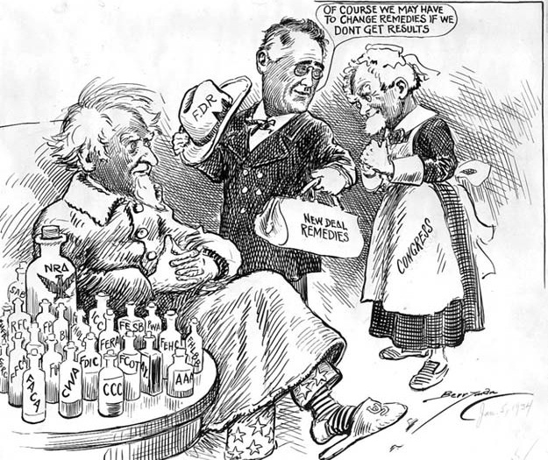
Document #1:

Document #2: U.S. Unemployment Rate Chart, 1930-1945
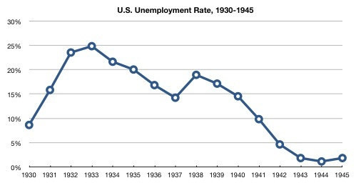

Document #3:
U.S. Senator Huey Long, from Louisiana, became a vocal critic of FDR and the New Deal during Roosevelt’s first term, in the depths of the Depression. The following is from a radio speech given by Long in January of 1935 and later printed in the Congressional Record.
“We owe debts in America today, public and private, amounting to $252 billion. That means that every child is born with $2,000 debt tied around his neck… We propose that children shall be born in a land of opportunity, guaranteed a home, food, clothes, and the other things that make for a living, including the right to education.” -Louisiana Senator Huey Long

Document #4:
“In time it became clear that he had changed the fabric of American society and done much to alter the American spirit of self-reliance…replacing it with a reliance on the government instead. The Protestant work ethic and Rugged Individualism that made America great has been replaced with this New Deal that has made men serfs to the government.” -- Historian Edgar E. Robinson, 1955

