Unit #14: The Early Cold War Review Sheet (1945-1954)

After World War II, America and The Soviet Union (Russia) were the only two superpowers left in a devastated world. However, America, a capitalist and democratic country and Russia (known as The Soviet Union – U.S.S.R.) a Communist country, wanted to shape the post-war world in a way that would benefit them the most – either spreading capitalism or communism. This started The Cold War – a war in which the two sides never fought each other, but fiercely competed in the arms race, space race and to protect and spread their ideologies across the world. As World War II was ending, the Soviets were marching to Germany from the East, and the Americans from the West. At the Yalta Conference (February 1945), the Big Three (America, Great Britain and Russia) agreed to let all of the countries they liberated from the Nazis stay free. However, after Franklin Roosevelt died, Stalin broke the deal and at the Potsdam Conference (May 1945) he told British Prime Minister Winston Churchill and new U.S. President Harry S. Truman that he will keep his soldiers in the Eastern European countries and they will become part of a new Soviet Empire. World War II was over, but Europe was split in two – the West being capitalist, democratic and free, but the East becoming Soviet Satellite States behind what was now known as the Communist “Iron Curtain.”
To stop the spread of Communism, U.S. President and The National Security Council developed NSC-68 or The Containment Policy – stating that America will help other countries’ stop communism from spreading into them. President Truman gave a speech known as The Truman Doctrine, which emphasized this. His Secretary of State George Marshall developed The Marshall Plan to give financial aid to countries. Germany was the center of the Cold War. Berlin, the capitol of Germany, was split into a free West and a Communist East. Russia tried to starve West Berlin by blockading it (Berlin Blockade), but America helped West Berlin with The Berlin Airlift. The U.S. also developed The North Atlantic Treaty Organization to protect European countries from Communism. In response, the USSR formed the Warsaw Pact with its satellite nations.
President Dwight D. Eisenhower began a policy known as The Domino Theory – this followed the containment policy; warning that if America did not stop Russia from spreading communism, neighboring countries would fall. Eisenhower’s Presidency also saw the start of The Space Race, with Russia launching The Sputnik Satellite. America would win the space race under President Richard M. Nixon, when America landed on the moon first (1969). On the home front during Eisenhower’s Presidency, there was another Red Scare and wave of McCarthyism, where many Americans were suspected of being Communists and Russian spies. People also became conformist to fit in and show they were true Americans.
In 1949, China became Communist when Chairman Mao Zedong overthrew the Democratic Government. To avoid a Communist Domino effect in all of Asia, the United States needed to make a stand in Asia. From 1950-1953, America fought The Korean War, protecting capitalist South Korea, from Communist North Korea. This was one of two proxy (side) and limited wars (limited objectives America fought to protect its Democratic friends from Communism. In 1954, America began getting involved in Vietnam (which, like Korea, was split into a Communist North and Capitalist South), when the North tried to unite the country under Communism. From 1965-1975, America fought The Vietnam War, trying to protect capitalist South Vietnam from Communist North Vietnam, but unfortunately failed to do so, and Vietnam and eventually most of South East Asia became Communist.

Part I. Copy the Keywords and their Definitions:
1) Potsdam Conference – Meeting between Big Three where Stalin stated he will keep soldiers in Eastern Europe and make them satellite nations (nations under Soviet control).
2) Cold War - where the Superpowers of America and Russia competed with each other for global dominance and to spread capitalism vs. communism.
3) Arms Race - Competition between America and the Soviet Union to build their armies and nuclear weapons arsenal
4) Space Race – Competition between America and the Soviet Union to send satellites and space ships into space and to land on the moon (U.S. wins) Begins when Russia launches the satellite Sputnik into orbit.
4) National Security Council – special Congressional/military panel to advise the president on military matters.
5) NSC-68/Containment Policy – American foreign policy to contain the spread of Communism.
6) Marshall Plan – Secretary of State George C. Marshall’s Plan to send financial aid to limit the spread of Communism (used to help Greece and Turkey).
7) Berlin Airlift – America and its Allies efforts to help Western Berlin from Soviet Berlin Blockade.
8) Berlin Blockade -- when the Soviets blockaded West Berlin to try to control entire city.
9) The Truman Doctrine – President Truman’s speech (and new foreign policy) announcing that America will stop Communism wherever it tries to spread.
10) The North Atlantic Treaty Organization (NATO) – Military Alliance between America and democratic Western European countries to protect each other from a Russian attack.
11) Warsaw Pact – Military Alliance between USSR and its Eastern European Satellites to protect each other against a Western attack.
12) Iron Curtain – metaphorical division between Democratic Western and Communist Eastern Europe. All communist nations were considered “behind the iron curtain.”
13) The Domino Theory – Foreign Policy (mostly applied to Middle East and South East Asia) under Eisenhower that said that if one country falls to Communism, other countries will as well.
14) McCarthyism – when Senator McCarthy led a committee that found and persecuted possible Communists and accused many of being communists.
15) Second Red Scare – When people were scared of Russian/Eastern European immigrants of possibly being Communist spies.
16) House of Un-American Activities Committee (HUAC) – Congressional committee to try to find communists and Russian spies.
17) Conformity – adjusting your lifestyle to fit in with “what is normal.” Heavily done during the 1950’s.
18) Korean War (1950-1953) – Limited War (war with specific objectives) and Proxy War (not a direct war between America and Russia) where America stopped Communist North Korea from invading capitalist South Korea.
19) 38th Parallel – Latitude line that divided North from South Korea.
20) Vietnam War – Proxy War when America tried to stop North Vietnam (Communist) from conquering South Vietnam. America lost the war and 58,000 soldiers.
21) Rosenberg Trial: When Julia and Ethel Rosenberg were convicted and executed for being Communist spies.

Part II: Document Analysis: Read and analyze the following documents and answer the question below in one full T.E.A.L. paragraph (5-7 sentences) each citing and analyzing at least TWO (2) documents in EACH question:
Homework Question #1: Describe the historical circumstances leading to the “Second Red Scare” (or McCarthyism) in the United States?
Homework Question #2: Based on the documents, analyze how the audience of the American public is trying to be affected and persuaded.

*****Documents are on next page****

Document #1:
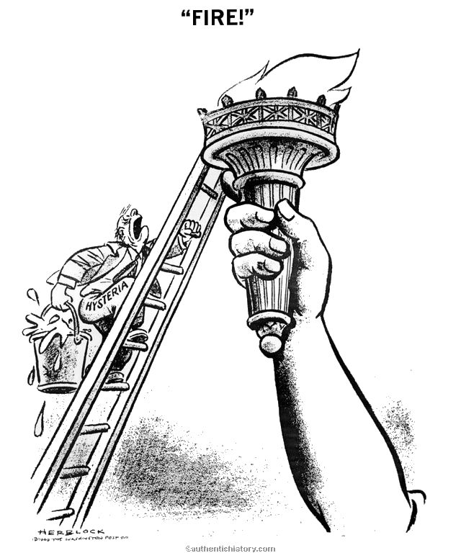

Document #2:
“Five years after a world war has been won, men should be expecting a long period of peace, and men’s minds should be free from the worries of war. But this is not a time-period of peace. This is a time of the ‘cold war’ . . . the reason why we find ourselves in a position of weakness is because of the actions of traitors within our own country. This fact is obviously true in the State Department. In my opinion, the State Department is completely infested with communists. I have in my hand 57 cases of people who are suspected members of the Communist party, yet they are still part of our government – in the State Department.”- Senator Joseph McCarthy, 1950
Document #3
“The American people are sick and tired of being afraid to speak their minds or they will politically smeared as communists or Fascists by their opponents, freedom of speech has been abused by some.”- Senator Margaret Chase Smith, 1950
Document #4
“[McCarthy is just] confusing the public mind, as between the internal and the external threats of Communism. We must not confuse dissent (disagreement) with disloyalty. We must remember always that accusation is not proof and that conviction depends upon evidence and due process of law. We will not walk in fear, of one another. We will not be driven by fear into an age of unreason… We proclaim ourselves, as indeed we are, the defenders of freedom, wherever it continues to exist in the world, but we cannot defend freedom abroad by deserting it at home. The actions of the junior Senator from Wisconsin have caused alarm and dismay amongst our allies abroad, and given considerable comfort to our enemies. And whose fault is that? Not really his. He didn't create this situation of fear; he merely exploited it—and rather successfully.”- Edward R. Murrow

