Unit 17 Extra Credit

Issue Overview: Obamacare
By Bloomberg, adapted by Newsela staff, October 2016
Read the following article and answer the questions that follow in one paragraph each:
- Why is healthcare a critical issue for all Americans?

- To what extent do you support keeping the Affordable Care Act as it is, changing it or repealing it, as President Trump wants to do, and replacing it with something else? Explain.
The Affordable Care Act (ACA) went into effect as a law in 2013. Called Obamacare, it succeeded in cutting down the number of Americans who don't have health insurance. It also survived a series of challenges in the Supreme Court that threatened to sink it. Obamacare now faces its biggest threat yet with the election of Donald Trump. The Republican president-elect has vowed to overturn Obamacare, which he has repeatedly called "a total disaster." He says he will replace it with a more basic plan. Democrats in the Senate say they'll do their best to block any attempts to tear down the law, which was one of the main achievements of Barack Obama's presidency. The question is how the law has and has not met its ambitious goals: to give more people health insurance while changing a medical system that spends more and delivers less than that of any other wealthy country in the world.

The Situation
Obama has said that 20 million people gained coverage through three parts of the ACA. The first was the health care exchanges. People buy individual insurance plans from insurance companies through these online marketplaces. The second was the enlargement of Medicaid, a health plan for the poorest Americans, and a similar children's program. The third was a rule that allowed young adults to stay on their parents' plan until age 26. A number of surveys have found that the uninsured rate has fallen roughly in half, and now just about 10 percent of Americans are uninsured. The cost of coverage, however, has been high. The price of Obamacare plans is set to rise by about 22 percent on average for next year. Still, about 77 percent of people who are on Obamacare would still be able to find ACA plans for less than $100 a month once money given by the government is included. And the cost of insurance offered through employers — where most people get their insurance — rose only about 3 percent this year. However, consumers are having to pay more of the cost of care themselves.
Medical spending: The growth rate of the nation's spending on health care has slowed. The decline started shortly before passage of the law. Economists say at least part of that change may be attributed to Obamacare. It encourages people to stay in the hospital a shorter time and limits medical care that is not needed. The White House estimates that the growth rate of health care costs has slowed slightly because of the ACA. Competition: Even before the election, several large insurance companies, including Aetna and UnitedHealth Group, decided to not to participate in many of the exchanges. The insurance companies said they were losing too much money. At least 1.4 million people will lose the Obamacare plans they bought in the health exchanges for 2016, forcing them to pick new plans for 2017.
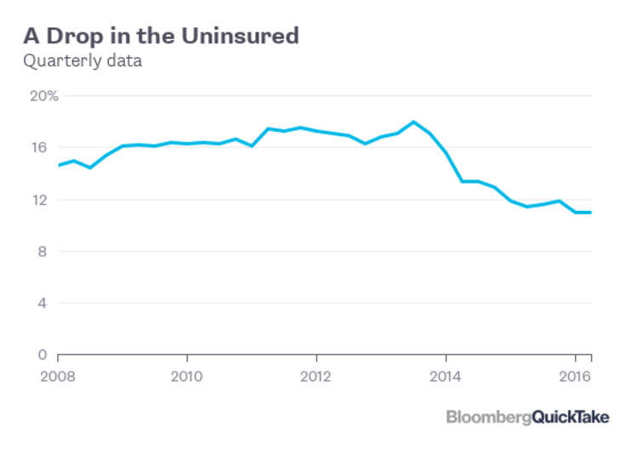

The Background
The government faced a problem when it created Obamacare. It wanted to keep the country's current system, where most of the people get insurance through their employer. Meanwhile, it wanted to ensure health care for people too poor or sick to afford it. Making it work required a combination of three things. First, the government gave money to middle-income workers to help them buy insurance. Second, it spent more on Medicaid to cover more low-wage workers. Third, it forced Americans to get health insurance or pay a fine. For the insurance exchanges to work, insurance companies had to have enough healthy customers to balance out the high cost of sicker ones. Most people liked the promise that no one would lose their insurance because they were sick. They also liked the rule that allowed young people to stay on a parent's plan until age 26. But the law itself never became really popular. During the presidential campaign, Trump's Democratic opponent, Hillary Clinton, proposed expanding coverage. She wanted to give people more money and start government insurance plans to compete with ones run by companies.

The Argument
During the campaign, Trump did not really say how he would replace Obamacare. He said he would drop the government subsidies that pay for part of the plans. Instead, he would allow people to deduct the cost of their insurance from their taxes. He would also give some money to the states to pay for Medicaid. Trump said this would save money. He also wants insurance to be sold across state lines, something he said would increase competition and improve coverage. Right now, insurance companies can only sell in their own states. The Commonwealth Fund, a nonprofit organization, looked at what would happen if the ACA was repealed. It found that about 20 million people could lose their health insurance and $33 billion a year would be added to the federal deficit. The Trump campaign disputed the report.

