Unit 3: Building A New Nation (1789-1824)

After the Constitution was ratified, the representatives unanimously elected George Washington to be America’s first President. Washington knew that he would be setting important precedents (important firsts). Washington was the first person to create a cabinet (groups of advisors and specialized departments). This was part of the Unwritten Constitution (powers not specifically listed in the Constitution). Washington set another example on the homefront by demonstrating the Federal Government would exercise their power to strike down domestic uprisings during the Whiskey Rebellion. Another part of the Unwritten Constitution that Washington establishes is that Presidents only serve for two terms – after Washington’s second term, he chose not to run again. His Farewell Address, at the end of his presidency is also important because in it, Washington outlines a policy of isolationism – warning America to stay away from foreign affairs. Washington also established Future Presidents would both follow and debate this policy. Washington also warned against political parties, but people took sides over political issues and eventually formed the Federalist Party and the Democratic-Republicans. In 1796, John Adams defeated Thomas Jefferson to become the 2nd President. During Adams’ Presidency, America almost went to war with France over the XYZ Affair and in response Adams passed the Alien and Sedition Act which limited rights during time of war. The election of 1800 saw the peaceful transfer of power between two presidents after Adams lost to Jefferson (this was known as “The Revolution of 1800). In 1803 the 3rd U.S. President, Thomas Jefferson, made the Louisiana Purchase from the French Emperor Napoleon. This purchase, which Jefferson made Constitutional by calling it a treaty, more than doubled the territory of the U.S. The Louisiana Purchase demonstrates that Jefferson changed his original view that the constitution should be interpreted strictly to that it should be interpreted loosely. This treaty between the US and France gave the U.S. full control of rich natural resources and the Mississippi River and the port of New Orleans. This rich and plentiful land was attractive to many American settlers.
As America began expanding, it began having problems. England began instigating America and America’s 4th President, James Madison, declared war (with Congress’s approval) on England. This became known as The War of 1812. It was a draw, but its long term significance is that America established itself as a legitimate power. America used its new power to protect its interests. In 1823, President James Monroe in his State of the Union Address to Congress issued the Monroe Doctrine which declared that the Western Hemisphere was not allowed to be colonized any more by the European Powers – this was now America’s area. It is debated if the policy was expansionist (expanding America’s power) or keeping with George Washington’s policy of isolationism. Regardless, America, in just under 40 years as a nation, was becoming a powerful country.

Important Vocabulary: Write the terms and definitions in your HW notebook
1) Precedent – something done that is followed by others.
2) Unwritten Constitution – powers, procedures and traditions that become precedent but are not specifically listed in the Constitution. Many of Washington’s precedents (such as a two-term President and a Cabinet) become part of the Unwritten Constitution
3) Cabinet – the President’s group of political advisors. (part of unwritten Constitution)
4) Whiskey Rebellion – farmers’ rebellion over a whiskey tax. President Washington uses the army to put down the rebellion to show the strength of the Federal Government.
5) Farewell Address – Washington’s letter to the nation when he chooses not to run again. In it, Washington stresses a future policy of isolationism/neutrality and warns against political parties.
6) Isolationism – a policy of neutrality – America should not be involved in foreign affairs.
7) Political Parties – organizations that represent a set of political (and social and economic) beliefs. The first two political parties where the Federalists and Democratic-Republicans.
8) XYZ Affair – When France tried to blackmail America to pay France to stop attacking ships. Leads to “The Quasi-War” between America and France.
9) Alien and Sedition Acts – Acts passed by President Adams that limit rights and speech against the government during time of war and are anti-immigrant.
10) Revolution of 1800 Jefferson defeats Adams in the election of 1800. Adams peacefully transfers the Presidency to Jefferson. This is the first peaceful political exercise of democracy/exchange of office in American history.
11) Louisiana Purchase a treaty President Thomas Jefferson made with France that doubled the size of the U.S and gave the U.S. full control of the Great Plains, Mississippi River and New Orleans.
12) Strict Constructionist - a person who interprets the Constitution exactly as it is written, word for word.
13) Loose Constructionist- a person who interprets the Constitution in a loose flexible way and may stretch the meaning of the Constitution.
14) War of 1812 – A war between the US and England which was fought over trade rights. The US barely won and the White House was burned down. The significance is that America is now respected as a legitimate and powerful nation.
15) Alexander Hamilton – advisor to President Washington who supported the creation of a National Bank
16) Lewis and Clark - explorers hired by President Jefferson explore the Louisiana Territory
17) State of the Union Address – Part of the unwritten Constitution – the President addresses Congress (and now the nation) and tells them his plans for America, what he wants done, etc.
18) Monroe Doctrine- This was the nickname for President Monroe’s State of the Union Address that said that Europe should not interfere with the West (North & South America), the Western Hemisphere is the U.S.’s area, and the U.S. would not get involved in European affairs.
19) Domestic Policy – Government policy that affects issues inside of a country
20) Foreign Policy – Government policy that affects relations with other countries

Study Questions: Answer the following study questions in one T.E.A.L. paragraph each (5-7 sentences, using specific details from at least two documents per question to support your answer). Be sure to not just use information and quotes from the document, but to then analyze them to answer the question as well.

Question #1: What are the geographic circumstances that shaped early American foreign policy?

Question #2: How did early American foreign policy affect our development and influence our relations with foreign nations?

*****Documents on Page 3*****

Document #1: George Washington Farewell Address to the Nation, 1799
“[Future presidents of the United States, you should] observe good faith and justice toward all nations; develop peace and harmony with all. Hatred to one nation can cause bloody wars. Being too friendly with another nation can cause evils. Having favorite nations will lead to wars. While we should make ourselves richer through commercial relations [such as trade and business], we should have as little political connection as possible. We already have some arrangements with some countries. Let us stop there. It would not be smart to associate ourselves politically with European countries. Above all, let’s steer clear of permanent alliances with the foreign world.”

Document #2: Map of the Louisiana Purchase
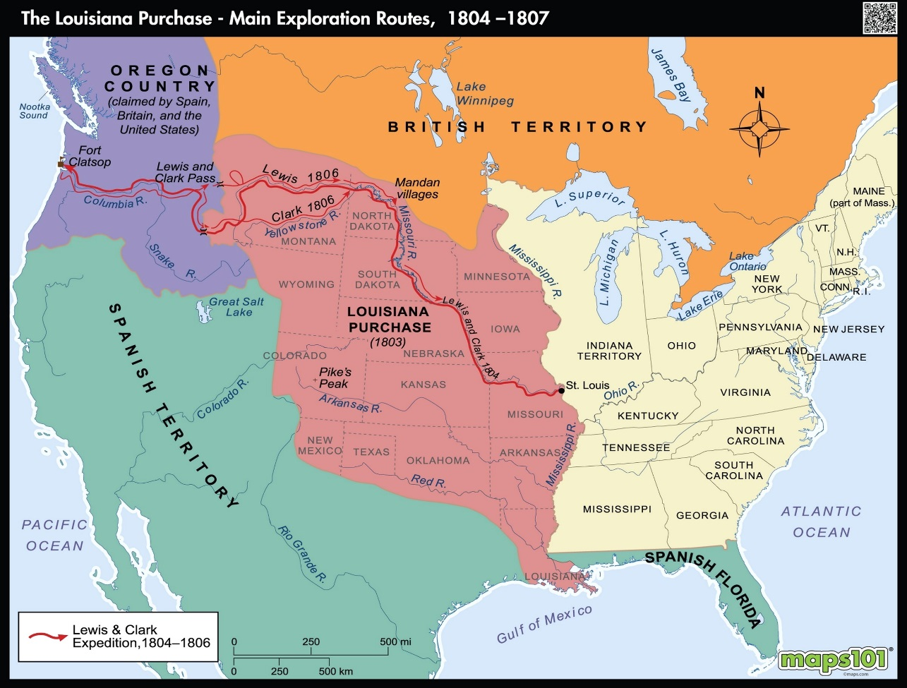

Document #3: Monroe Doctrine Cartoon, 1902
