Unit 8 and 9 Overview: Turn of the Century: Nationalism, Imperialism and Progressivism (1890’s-1914)

The Progressive Era is a period of reform in which many of the problems that the U.S. faced during industrialization were addressed or solved. During industrialization, it was common for children to work in unsafe factories alongside their parents who would work 70-80 hours a week. Life at home wasn’t any better as most American were poor, ate spoiled food and lived in crowded, dirty tenements. During The Progressive Era, the U.S. government moved away from its Laissez-faire policy and began to regulate businesses. The movement grew from the Granger Movement and Populist Party that organized farmers in an attempt to break up the railroad monopoly that had been exploiting (taking advantage of) farmers by overcharging them for shipping. The Populist Platform called for more popular involvement in government such as direct election of senators, initiative, referendum and recall. Even though they lost, they paved the way for many reforms.
The Progressives were a political, social and economic movement, which fought for the poor and working class people that were being exploited during industrialization. Many writers, reporters, and social activists like Upton Sinclair and Jacob Riis contributed to solving the many problems that developed during industrialization. Workers began to group together in labor unions in order to fight for better wages, shorter work hours, and safer working conditions. The public and government did not support unions at first but key events like the Triangle Shirtwaist Factory Fire eventually made people realize that workers' rights were being violated by big businesses. Presidents read the works of the Progressive writers and made reforms based on their writings; they became known as The Progressive Presidents. President Theodore Roosevelt is considered to be the American President at this time most responsible for protecting Americans from the abuses of business. Roosevelt worked tirelessly to pass Anti Trust Acts, improve health and safety conditions in factories and make sure the food we eat is safe. President William Howard Taft and Woodrow Wilson were also Progressive Presidents who passed reforms.
The Progressive movement continued to 1920 when women received the right to vote with the passing of the Nineteenth Amendment. However, the Progressive Movement ends when America enters World War I.
At the same time the Progressive Movement was trying to fix America’s domestic issues that came as a result of industrialization, that same industrialization and increased nationalism was changing America’s foreign policy. America's first foreign policy was set by President George Washington who favored neutrality while the U.S. was still young and weak. However, as early as 1823, when the Monroe Doctrine (the State of the Union by President James Monroe) declared Latin America off limits to further European colonization, the U.S. had begun to move away from neutrality.
By the late 1800s many factors (especially industrialization and the settling of the frontier) began to push the U.S. further away from neutrality and towards expansion and imperialism.
The US had long wanted control of the Spanish colony of Cuba that lay only 90 miles south of Florida for both military and economic purposes. A Cuban uprising against Spanish rule led the U.S. to send the U.S.S. Maine battleship to Cuba. When the ship mysteriously exploded, yellow journalists were quick to blame Spain so the U.S. would have a reason to declare war on Spain. The U.S. emerged from the Spanish American War with the colonies of Puerto Rico, Guam, and the Philippines. The U.S. also annexed (absorbed) Hawaii in 1898 and expanded business opportunities into China. President Theodore Roosevelt wanted America and the European powers to share China and they all agreed on an Open Door Policy in which they would divide China into Economic Spheres of Influence.
America was now ready to expand both into Latin America and Asia. In Latin America, Theodore Roosevelt issued The Roosevelt Corollary to the Monroe Doctrine which was an addition to the Monroe Doctrine that gave America the power to intervene in Latin American affairs and protect our economic and political interests there. To protect our interests, Roosevelt practiced a Big Stick Policy, threatening force when necessary. Using this policy, we used the military several times in different Latin American countries. Roosevelt also began production on the Panama Canal to connect our Latin American and Asian/Pacific Empires. After Roosevelt, President William Taft did not want to use military force so practiced Dollar Diplomacy, using America’s economy to control the smaller economies of Latin America.

1) The Granger Movement - farmers who pushed for government regulation of railroads
2) The Populist Party – a new political party started by William Jennings Bryan to represent workers and farmers against railroads, banks and big business, and to get political reforms.
3) The Progressive Movement – Movement where people (Muckrackers) identified and fought against the social, political and economic problems in the United
States due to urbanization (growth of cities) and industrialization (growth of businesses)
4) Theodore Roosevelt - Progressive President (1901-1908) who’s Square Deal Policies broke up monopolies, created the Meat Inspection Act and was also a trustbuster – breaking up monopolies.
5) Trustbusting - when the government uses antitrust acts to break up trusts/monopolies
6) Anti Trust Acts - laws that tried to stop the spread of monopolies such as the Clayton Anti-Trust Act and Sherman Anti-Trust Act.
7) Meat Inspection Act (1906) - cleanliness requirements for all meat plants that were enforced with inspectors
8) Pure Food and Drug Act (1906) - required companies to label ingredients in food and drug products
9) Muckrakers - reporters who expose problems, corruption and the abuse of industry
10) Upton Sinclair - wrote The Jungle a book about the unclean and unsafe conditions of the meatpacking industry.
11) Jacob Riis - photographed the horrible living conditions of the urban poor in his book How the Other Half Lives
12) Initiative - allows citizens, instead of politicians, to come up with state bills (ideas for laws)
13) Referendum - allows citizens, instead of politicians, to vote on certain state bills
14) Recall - allows citizens, instead of politicians, to remove a politician from office
15) Seneca Falls Convention (1848) – a meeting of women, led by Susan B. Anthony to demand Women's Suffrage.
16) Suffrage - the right to vote. The 19th Amendment grants Women’s Suffrage
17) Labor Unions- Groups of workers who used the threat of going on strike in order to bargain for better working condition and higher salaries. (Terrence Powderly’s Knights of Labor, Samuel Gomper’s American Federation of Labor - AFL)
18) Triangle Shirtwaist Factory Fire (1911) - 150 women die in a factory fire because of unsafe conditions
19) Tenements – small, unsafe apartments that immigrants in NYC would often live in.
20) Boss Tweed and Tammany Hall - The corrupt government of New York City that took advantage of people and immigrants through taxes, corrupt deals, etc.
21) Thomas Nast – cartoonist who exposed corruption, especially against Boss Tweed.
22) Ida Tarbell – Wrote about the corruption of the Standard Oil Company.
23) Jane Adams – worked in Hull Houses that were houses for the poor.
24) Woodrow Wilson – another Progressive President. His “New Nationalism Program” targeted child labor, better working conditions, regulating banks and breaking up trusts.
25) Progressive Presidents – Presidents T. Roosevelt, W. Wilson and W. Taft; each of these tried to create important economic, social and political reforms to address the problems of the time.
26) Foreign Policy - a country's plan on how to deal with other countries (neutrality, imperialism, isolationism)
27) Imperialism- the policy of a country maintaining colonies or control over distant lands.
28) Big Stick Policy/Roosevelt Corollary (1904-1909) - declared that the U.S. could "police" the Caribbean and Far East to ensure U.S. economic interests were protected.
29) Open Door Policy - U.S. policy that stated that they had rights to operate and profit from business in China.
30) Panama Canal - a man made water way that was built to increase the power of the US navy and connect America’s growing Empire.
31) Yellow Journalism - propaganda or exaggerating news stories to make something exciting and convincing.
32) William Randolph Hearst and Joseph Pulitzer - reporters who used yellow journalism to help provoke the Spanish American War by blaming the sinking of the USS Maine on Spain.
33) Spanish American War (1898) – a war in which the U.S. easily defeated Spain and became a world power with control of Puerto Rico, Guam, and the Philippines.
34) Dollar Diplomacy – President Taft’s policy to use money to control Latin America.

Part II: Study Questions: Answer each question in one paragraph (5-7 sentences, using T.E.A.L. and specific evidence and analysis) each, using at least one document in each paragraph.

- Describe the historical circumstances of how American foreign policy is changing from isolation to imperialist/interventionist?

- Describe the historical circumstances of how American domestic policy is changing from laissez-faire to more government involvement?

- How do President Theodore Roosevelt’s policies reflect the changes in both American domestic and foreign policy?

Document #1: Big Stick in the Caribbean, 1904
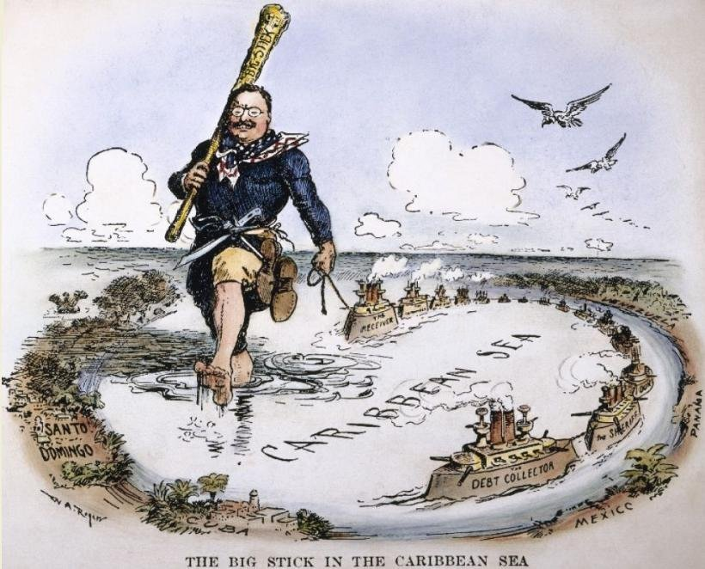

Document #2: 1907, “The President Dreams of a Successful Hunt”
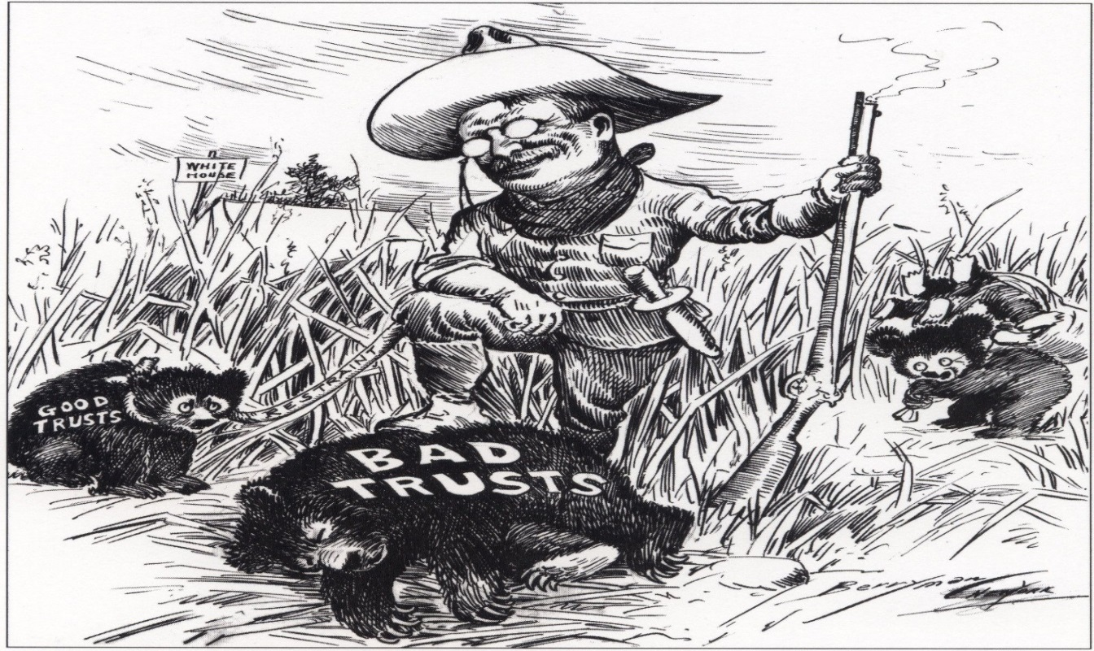

Document #3: Social and Industrial Justice Speech, Chicago, August 1912 – President Theodore Roosevelt
In the last twenty years an increasing percentage of our people have come to depend on industry for their livelihood, so that today the wage-workers in industry rank in importance side by side to the tillers of the soil [farmers]. As a people, we cannot afford to let any group of citizens or any individual citizen, live or labor under conditions which are injurious to the common welfare [well-being]. Industry, therefore, must submit to such public regulation as will make it a means of life and health, not of death or inefficiency. We must protect the crushable elements [regular workers] at the base of our present industrial structure. We stand for a living wage. Wages are subnormal if they fail to provide a living for those who devote their time and energy to industrial occupations. [Wages must] maintain the family during periods of sickness, and to permit a reasonable savings for old age. Hours are excessive if they fail to afford the worker sufficient time to recuperate and return to his work thoroughly refreshed. We hold that the night labor of women and children is abnormal and should be prohibited; we hold that the employment of women over forty-eight hours per week is abnormal and should be prohibited. We hold the seven-day working week is abnormal, and we hold that one day of rest in seven should be provided by law. We hold that the continuous industries, operating twenty-four hours out of twenty-four, are abnormal, and where, because of public necessity or for technical reasons (such as molten metal), the twenty-four hours must be divided into two shifts of twelve hours or three shifts of eight, they should by law be divided into three of eight.

